

The Peoples Republic of Bangladesh
Ministry of Health &Family Welfare (Health Service Division)
Health Economic Unit (HEU). Shasta Surakkha Kormochuci (SSK)
Topkhana Road, Dhaka-1000

Summary of the Visit of Lakshmipur Sadar Hospital and UHCs, Lakshmipur District by Team-5

1. We started for Lakshmipur on 11th September 2022 at 2:00 pm by Govt. transport. We arrived Lakshmipur at 9:30 PM. We returned back to Dhaka on 14th September 2022 at 3 pm and reached Dhaka at 10:30 pm.

2. The objectives of the visit were-
a) To perform the baseline health survey of the 100bedded Sadar Hospital, Raipur UHC and Ramganj UHC, discussion about the SSK program and importance of quality of health care with them.
b) To assess the progressive development of the quality of the health care, formation of Quality Improvement Committee (QIC), improvement of the quality by implementing the building blocks of C-J Model in Ramgati UHC and Kamalnagar UHC.

Date: 12/09/22 at 9am; Place: Raipur UHC (50 Bedded)

Activities and Findings:
- Total population:3,13,760, Union: 10
- Cleanliness of the hospital premises is average
- 7 posts including gynae and anesthesia are vacant
- DSF program is running
- X-ray, USG and ECG machine are well functioning
- There are spaces in emergency, SSK Booth and Pharmacy can easily be established there
Recommendations:
- The post of gynae and anesthesia consultant should be filled up immediately
- The local Pouroshova must take part in waste management
- Condemnation Board should work to destroy all unwanted items

Date: 12/09/22 at 1pm; Place: Ramganj UHC (31 Bedded)

Activities and Findings:
- Total population: 3,13,500, Union: 10
- The infra-structure of the hospital building is 50 bedded since 2012. Till now, there is no administrative approval for functioning as 50 bedded hospital
- The post of Gynae and Anaesthesia consultant is filled up, so caesarean section is performed
- There are spaces in emergency, SSK Booth and Pharmacy can easily be established there
Recommendations:
- The posts of 50 bedded human resource should get approved as it is necessary for starting SSK program
- Radiological services are non-functioning due to vacant post of Medical Technologist (Radiology). It should be filled up immediately.
- For better office management, the post of Head Assistant, Cashier and Accountant are very important. All the posts are lying vacant. It should be filled up immediately

Date: 13/09/22 at 9am; Place: Kamalnagar UHC (50 Bedded)

Activities and Findings:
- Discussion meeting regarding SSK program and the importance of quality of the health care and formation of QIC committee.
- Observed the development of UHC's healthcare services while performing a site inspection of the hospital.
- We have seen lot of improvements, such as those we had suggested on our earlier visit, including improvements to the cleanliness, beautification, and waste management systems.
Recommendations:
- For functioning of the OT service, deputation of gynae consultant should be cancelled.
- An anaesthesia consultant already working there. But there is no anesthesia machine and OT table
- It can be replaced from the other UHC where extra machine is available.

Date: 13/09/22 at 1pm; Place: Ramgati UHC (31 Bedded)

Activities and Findings:
- Discussion meeting regarding SSK program and the importance of quality of the health care and formation of QIC committee.
- We observed the progressive development of the healthcare services while performing a site inspection of the hospital like construction of new toilets, effective waste disposal system, beautification of ward and corridors, prepared liberation corner for hospital visitors etc.
Recommendations:
- The post of Gynae consultant should be filled immediately to develop effective maternal health services.
- The bed occupancy rate of the hospital is more than 100%. So, rooftop of the hospital can be used for ward and administrative offices by forming Tin-shed infra-structure.
- There are two places selected for SSK booth and pharmacy which needs reconstruction.

Date: 14/09/22 at 1pm; Place: Civil Surgeon Office
Activities:
- Discussed with him about the SSK program and role of the District Hospital and Upazila Health Complexes as well as the role of the health service providers in SSK.
- The Civil Surgeon was very cordial and he ensured us to provide necessary support to implement SSK services

Date: 14/09/22 at 1pm; Place: 100 Bedded Sadar Hospital

Activities and Findings:
- Though the hospital is 100 bedded, but is running with 50 bedded human resource since 2003. There is another 150 bedded infra-structure building is under construction.
- There are 11 posts of consultants but 6 are vacant including Gynae
- There is no post of cashier, accountant and statistician
- Cleanliness of the hospital premises and indoor was weak
- There are spaces for SSK Booth and Pharmacy close to the emergency department
Recommendations:
- The post creation of human resource of 100 bedded hospital is very essential
- For waste management, involvement of Pouroshova is necessary
- Condemnation Board should work to destroy all unwanted items
- There should be 24/7 facility for caesarean section.

Lakshmipur District, Bangladesh
(Established as a district: 28th Feb,1984)
N
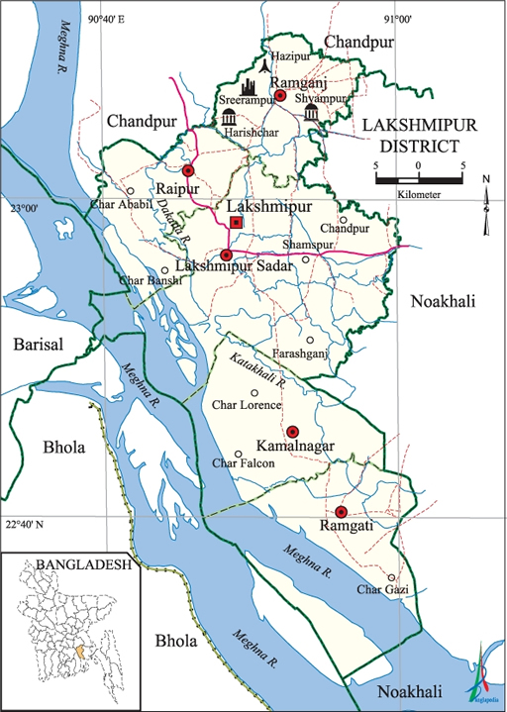

S
Fig: Map of Lakshmipur District

Visit Report: Civil Surgeon Office, Lakshmipur
Date of Visit: 14/09/22; Time: 8:30 AM
Visitor: Dr. Md. Emdadul Haque, National Consultant (HEU) &
Dr. Nazmur Rahman Sajib, Junior National Consultant (HEU)

1. We arrived at 8:30 am in the Civil Surgeon Office, Lakshmipur. We discussed with the Civil Surgeon about the overall activities of the health service system of the district. He is also in charge of Superintendent of the 100 bedded Lakshmipur Sadar Hospital.
2. We also discussed with him about the SSK program and role of the District Hospital and Upazila Health Complexes as well as the role of the health service providers in SSK.
3. The Civil Surgeon was very cordial and he ensured us to provide necessary support to implement SSK services.

Lakshmipur District Health Profile:
Total population: 19,38,111.
Upazilla: 5 Powroshova: 4 Union: 5

1. Sadar Hospital: 100 bedded.
2. Upazilla Health complex: 4 (Raipur UHC & Kamalnagar UHC are 50 Bedded, Ramganj & Ramgoti are 31 bedded).
3. Community Clinic: 179
4. Rural Dispensary: 21.
5. H & FWC: 30.

Status in HSS Score From Jan-July: (Total Dist. Hospital-64, Total UHC-423)
Name | Jan | Feb | Mar | April | May | June | July | Aug
Lakshmipur District Hospital | 2 | 1 | 2 | 2 | 3 | 3 | 55 | 55
Raipur UHC | 87 | 121 | 127 | 306 | 228 | 92 | 358 | 374
Ramganj UHC | 31 | 4 | 13 | 75 | 83 | 120 | 364 | 372
Kamalnagar UHC | 154 | 119 | 59 | 176 | 168 | 289 | 385 | 380
Ramgati UHC | 196 | 117 | 96 | 265 | 219 | 212 | 356 | 369

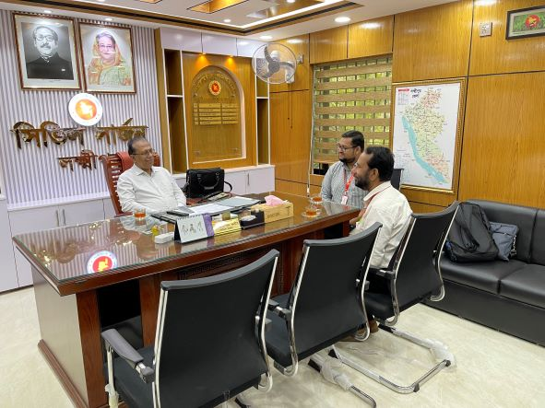
Fig: Meeting with Civil Surgeon cum Superintendent of Sadar Hospital, Lakshmipur

Visit Report: Raipur Upazila Health Complex, Lakshmipur
Date of Visit: 12/09/22; Time: 9:00 AM.
Visitor: Dr. Md. Emdadul Haque, National Consultant (HEU) &
Dr. Nazmur Rahman Sajib, Junior National Consultant (HEU)

Objectives of the visit:
1. To perform the baseline health survey of the UHC
2. Discussion on the SSK program and importance of quality of health care.

Activities:
1. We arrived in Raipur UHC at 9:00 am. All consultants and medical officers were present at the conference room of the UHC. We discuss with them about the SSK and overall situation of the health complex.
2. There are 10 unions under the UHC having 3,13,760 populations. There are two Sub-centers, 8 H&FWC and 34 Community Clinics in this Upazilla.
3. The infra-structure of this Upazila Health Complex is 50 bedded. Cleanliness of the hospital premises is average. We observed emergency, outdoor, pathology and pharmacy department. There is no separate section for male, female and children in OPD.
4. Out of 10 posts of junior consultant, 7 posts including gynae and anesthesia are vacant. Medical officer (Dental) post is vacant.
5. There is no cycle stand. There are many motorcycles parked in the premises.
6. The information display system was weak. Most of the information is handwritten. They are being advised to use Pana/notice board to display information. There is no corner for health education for OPD patients and their attendants.
7.The X-ray, USG and ECG machine are well functioning. In OPD, some of the medical officers performing USG on regular basis.
8.The spaces of emergency is satisfactory. There are some spaces close to the emergency room where SSK Booth and Pharmacy can be established. There are separate O.T room and labor room. There is an extra functioning anesthesia machine in the OT room.
9. Cleanliness of the hospital premises, outdoor and indoor was not satisfactory. waste management system needs to be improved.
10. There are spaces for SSK booth and pharmacy close to the emergency dept.
11. In 2021, total OPD patient was 98,698, in emergency 4476 and in indoor admitted patient was 6697. Bed occupancy rate was 79%. Total ANC 1st visit in 2021 was 1415 and total delivery was 507.

Health Profile of Raipur UHC:
Total population: 3,13,760
Union: 10 Sub-centre: 2 FWC:8 Community Clinic: 34

Human Resources: 50 Bedded Hospital:
Sl. | Designation | No. of Post | Present | Vacant
1. | UH&FPO | 01 | 01 | 0
2 | RMO | 01 | 01 | 0
3. | Junior Consultant | 10 | 03 | 07
4. | Medical Officer (incl. sub-centre) | 08 | 07 | 01
5. | MO(Dental) | 01 | 0 | 01
6. | Medical Officer (OSD) | 0 | - | -
7. | Nurses | 31 | 22+1 in deputation outside | 09
8. | Mid wives | 04 | 03 | 01
9. | Medical Technologist (Lab) | 04+1 | 01+1 | 03
10. | MT EPI | 01 | 01 | 0
11. | MT(Dental) | 01 | 01 | 0
12 | MT (Radiology) | 01 | 0 | 01
13. | SACMO (UHC + Field) | 12 (2+10) | 09 | 03
14. | Pharmacist | 02 | 01 | 01
15. | Health Inspector (HI) | 04 | 0 | 04
16. | Sanitary Inspector | 01 | 01 | 0
17. | Assist. Health Inspector | 11 | 08 | 03
18. | Health Assistant | 55 | 29 | 26
19. | CHCP | 34 | 31 | 03
20. | Head Assistant | 01 | 0 | 01
21. | Cashier | 01 | 0 | 01
22. | Accountant | 01 | 0 | 01
23. | Statistician | 01 | 01 | 0
24. | Office Assistant /Comp. Operator | 03 | 0 | 03
25. | Store Keeper | 01 | 0 | 01
26. | Cardiographer | 01 | 01 | 0
28. | MLSS+ Ward boy | 06 | 01 | 01
29. | Cleaner | 05 | 03+ 1 in deputation outside | 02
30. | Guard | 02 | 02 | 0
31. | Gardener | 01 | 01 | 0
32. | Cook | 02 | 0 | 02
33. | Attendant (Lab, Emergency, OT) | 03 | 03 | 0
34. | Driver(Ambulance) | 01 | 01 | 0
35. | Outsourcing: Driver(1+6)=7 | 07 | 07 | 0
36 | FWV | 11 | 10 | 01
37 | FPI | 07 | 06 | 01
37. | FWA | 47 | 36 | 11

Status in HSS Score From Jan-July (Total Dist. Hospital-64, Total UHC-423)
Name | Jan | Feb | Mar | April | May | June | July | Aug
Lakshmipur District Hospital | 2 | 1 | 2 | 2 | 3 | 3 | 55 | 55
Raipur UHC | 87 | 121 | 127 | 306 | 228 | 92 | 358 | 374
Ramganj UHC | 31 | 4 | 13 | 75 | 83 | 120 | 364 | 372
Kamalnagar UHC | 154 | 119 | 59 | 176 | 168 | 289 | 385 | 380
Ramgati UHC | 196 | 117 | 96 | 265 | 219 | 212 | 356 | 369

Status of Building Blocks of C-J Model in the Raipur UHC:
Sl | Criteria of C-J Model | Satisfactory | Average | Not Satisfactory
01 | Cycle stand close to the main gate |  |  | √
02 | Health Education |  |  | √
03 | Cleanliness & beautification |  | √
04 | Separation of patients in out door & indoor |  |  | √
05 | Blood doner list with 24/7 B.T facility |  | √
06 | Birth- death recording |  |  | √
07 | Reception Desk |  |  | √
08 | Developed Emergency Dept. | √
09 | 5S –KAIZEN implementation. |  |  | √
10 | Community Participation. |  | √
11 | Hospital activities Display |  |  | √
12 | Corner based service. |  | √
13 | Cash counter for receiving Govt money. |  |  | √
14 | Devolped maternal health/labour word. |  | √
15 | Devolped paediatric health |  |  | √
16 | Position in HSS score in July, 22. (Best= <100; Good= 101-200; Weak= >200) |  |  | √
17 | Power point Presentation &Video on UHC |  |  | √
18 | Knowledge about 8th Five Year plan & SDG. |  |  | √
19 | Zero-Tollarance on corruption |  | √

Recommendations:
1. Separation of OPD for male, female and children should be done to maintain quality of OPD services.
2. Rearrangement of male, female, labour and paediatric ward is necessary for maintain quality of indoor services.
3. The post of gynae and anesthesia consultant should be filled up immediately for the development of improved maternal health services.
4. All the vacant posts of 4th class should be fulfilled immediately.
5. Cleanliness and beautification is average. All unwanted posters should be removed. Condemetion Board should work to destory all unwanted items.
6. Hospital display system is weak. Most information are handwritten which needs to be replaced by notice board and pana.
7. The local Pouroshova must take part in waste management as health complex paid 13,00,000 Tk/year to Pouroshova.
8. There should be availability of safe drinking water for OPD patients.
9.The performance of all services must be improved, because of underutilization of the health complex.

Photos of Raipur UHC taken from the visit are shown below:
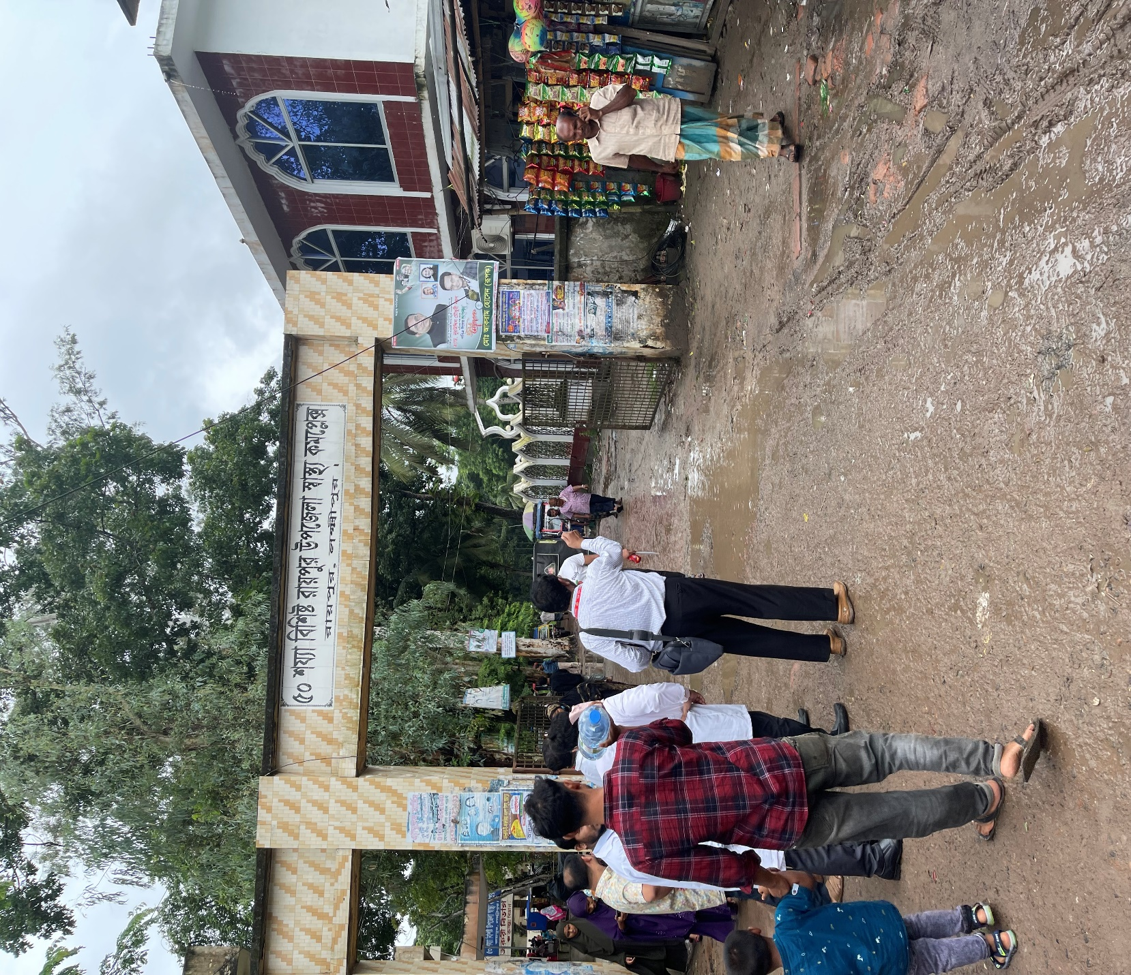
Fig-1: Front gate of Raipur UHC, but there is no guiding sign in the main road

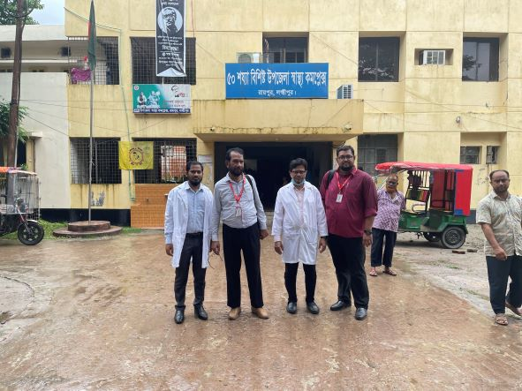

Fig-2: Entrance gate of Raipur UHC building

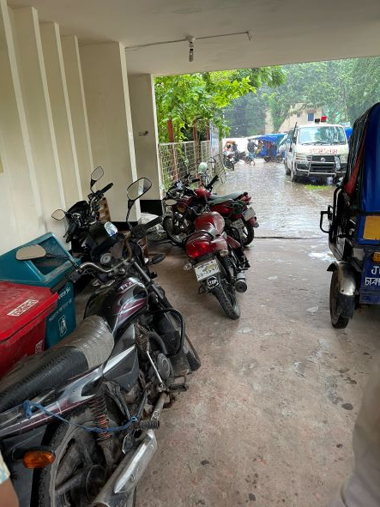

Fig-3: Motor cycle parked in front of hospital entrance

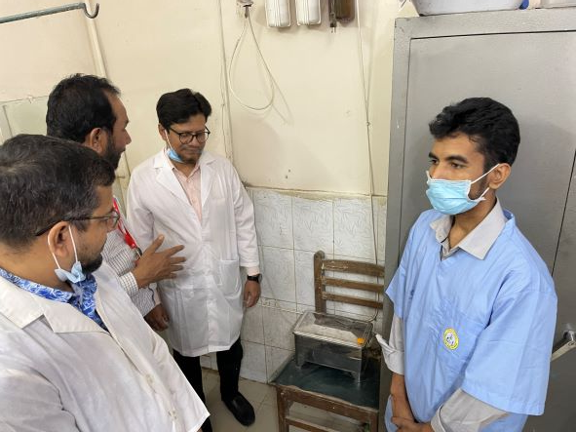
Fig-4: Sterilizer machine in the Emergency (Good Practice)

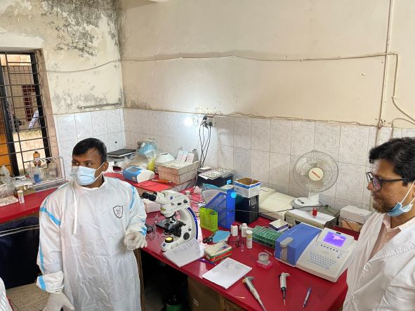

Fig-5: Pathology Lab; Medical Technologist (Lab) is using protective gown (Good Practice)
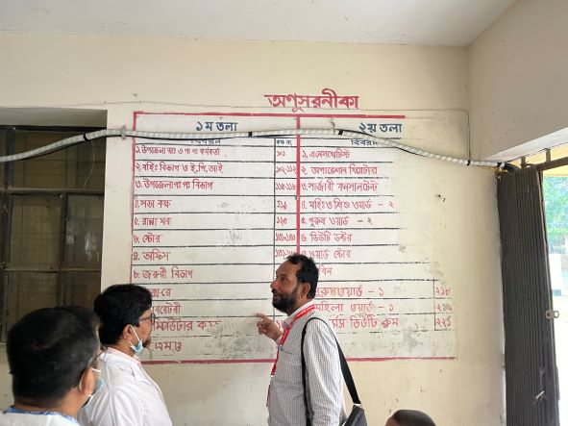
Fig-6: Direction should be written in a Pana board
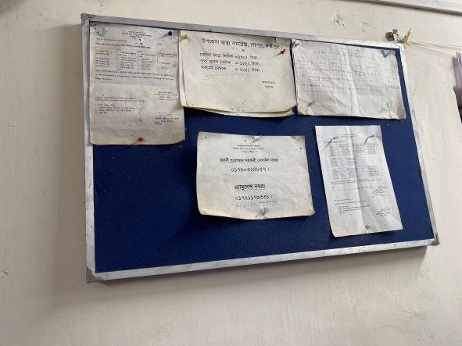

Fig-7: Display board should be digitalized with updated information

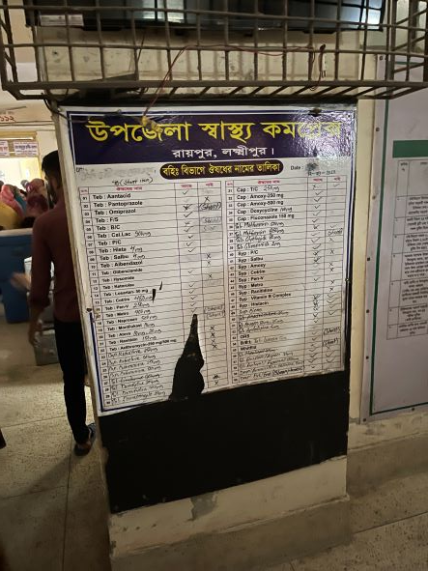

Fig-8: List of Supplied drugs for OPD; should be replaced with new one

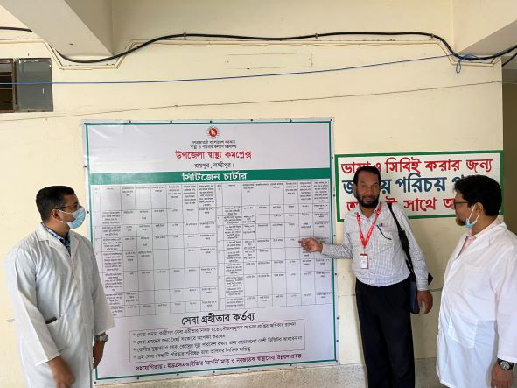

Fig-9: Citizen charter (Good Practice)

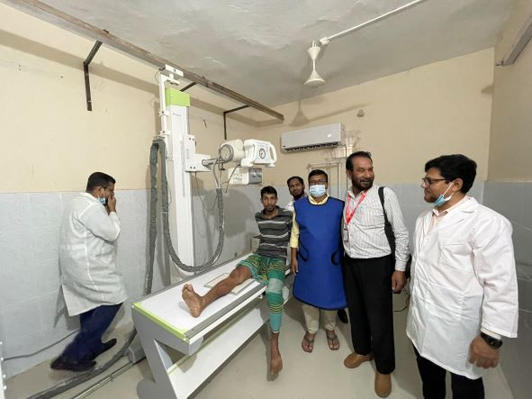

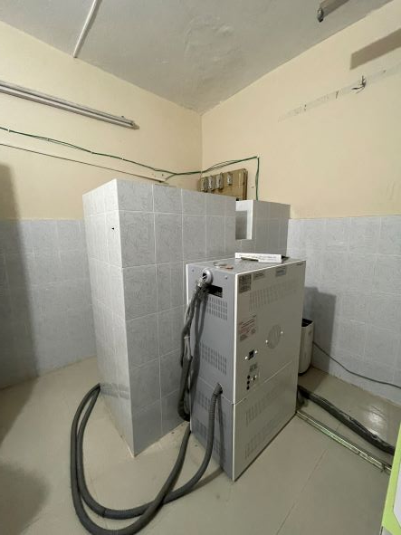

Fig-10,11: Functional X-ray room with medical technologist (Radiology) with developed protective system
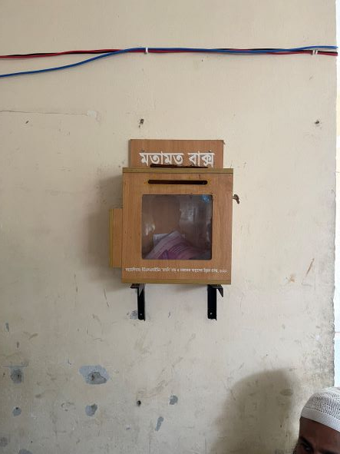

Fig-12: Suggestion Box (Good Practice)

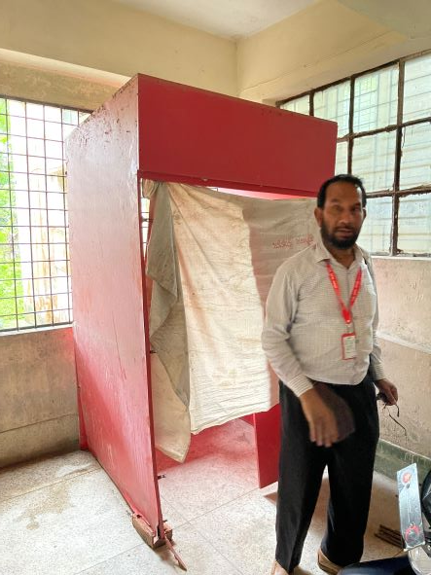
Fig-13: Unwanted item needs to be removed

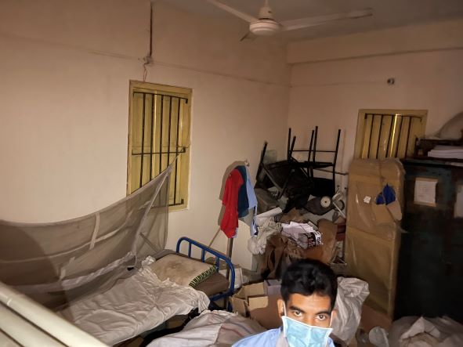
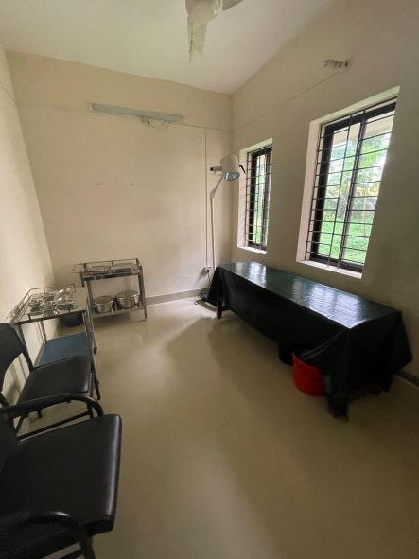

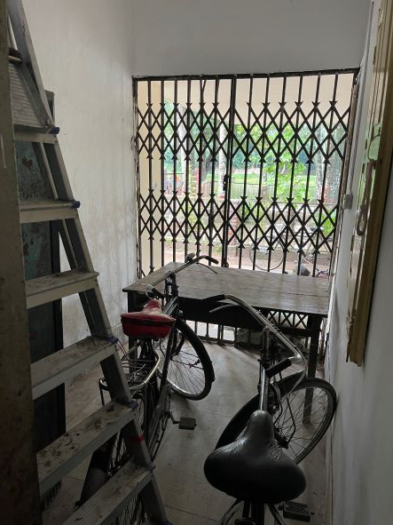

Fig-14,15,16: Proposed spaces for SSK Booth and Pharmacy

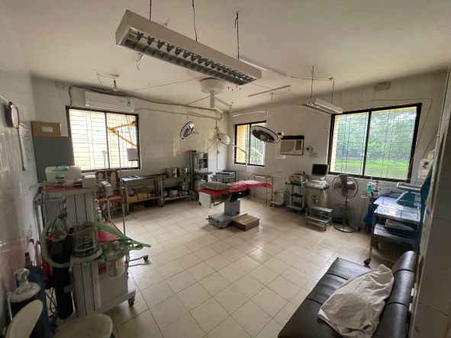
Fig-17: OT room; there are some unwanted items which occupy spaces
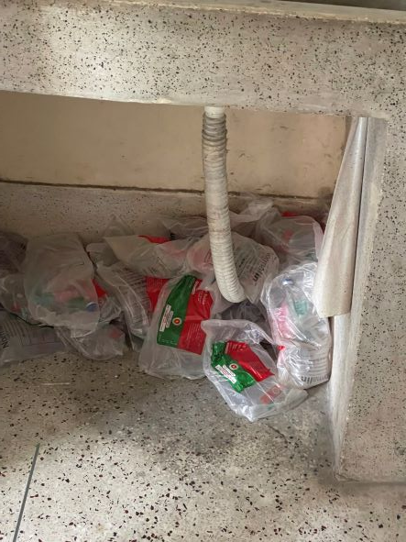
super

Fig-18: Supplied saline and other medicines should be stored in appropriate places

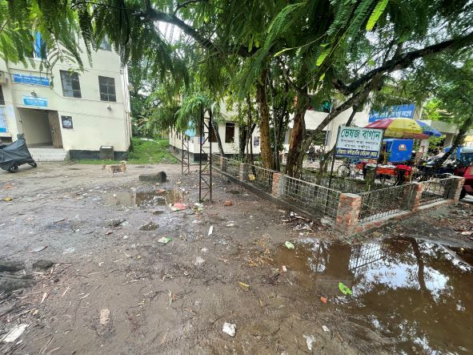

Fig-19: Proposed space for Cycle stand
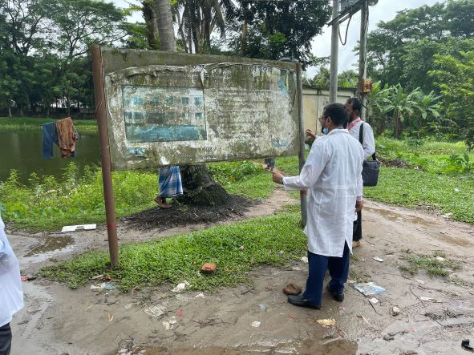
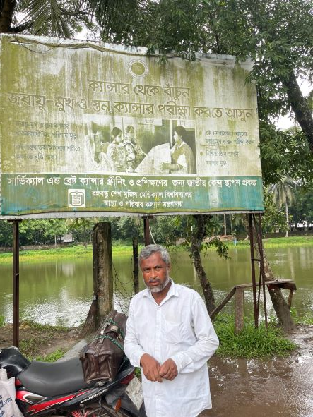

Fig-20,21: Unclean Bill board should be replaced by new health information
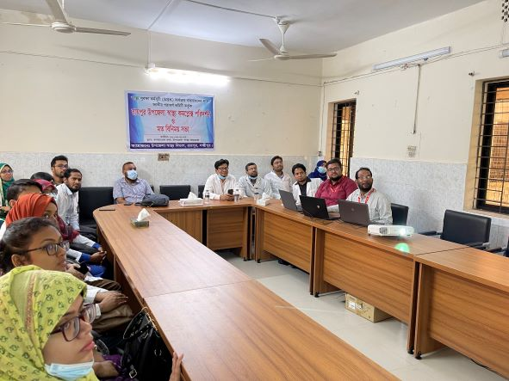
Fig-12: Discussion on SSK and quality of care with hospital staffs

Visit Report: Ramganj Upazila Health Complex, Lakshmipur
Date of Visit: 12/09/22; Time: 1:00 PM
Visitor: Dr. Md. Emdadul Haque, National Consultant (HEU) &
Dr. Nazmur Rahman Sajib, Junior National Consultant (HEU)

Objectives of the visit:
1. To perform the baseline health survey of the UHC
2. Discussion on the SSK program and importance of quality of health care.

Activities:
1. We arrived at 1:00 pm in the health complex. UH&FPO, RMO, medical officers and nurses were present in the health complex.
2. The Upazila Health Complex is 31 bedded. The infra-structure of the hospital building is 50 bedded since 2012. Till now, there is no administrative approval for functioning as 50 bedded hospital. But the condition is good. There are 10 unions under this UHC.
3. We met with the UH&FPO, RMO and other Medical Officers, discuss with them about the SSK and overall situation of the health complex. The post of Gynae and Anaesthesia consultant is filled up, so caesarean section is performed.
4. We visited outdoor of the Upazila Health Complex of Ramganj. The outdoor was crowded with patients. We observed OPD, Emergency, labour room, pathology and pharmacy department. There are one medical technologist (Lab). The information display system was better than any other UHC of Lakshmipur district, but the health education system is weak.
5. Cleanliness of the hospital premises and indoor was satisfactory. There is a separate operation theatre which is functioning.
6. There is no cycle stand close to the main gate. There are few motorcycles parked within corridor.
8. There are spaces in emergency, SSK Booth and Pharmacy can easily be established there.
10.The UHC was awarded by “Health Minister’s Award” in 2020.

Health Profile of Ramganj UHC, Lakshmipur
Total population: 3,13,500
Union: 10 Sub-centre: 8 FWC:2 Community Clinic: 27

Human Resources of Ramganj 31 Bedded Hospital:
Sl. | Designation | No. of Post | Present | Vacant
1. | UH&FPO | 01 | 01 | 0
2 | RMO | 01 | 0 | 01
3. | Junior Consultant | 04 | 03 (Medicine, Anesthesia, Gynae) | 1 (Medicine Deputation at DH)
4. | Medical Officer | 13 | 9 | 4
5. | MO(Dental) | 1 | 0 | 1
6. | Medical Officer (OSD) | 7 | 7 | -
7. | Nurses | 25 | 23 | 2
8. | Mid wives | 4 | 3 | 1
9. | Medical Technologist (Lab) | 2 | 1 | 1
10. | MT EPI | 01 | 1 | 0
11. | MT(Dental) | 01 | 0 | 01
12 | MT (Radiology) | 01 | 0 | 01
13. | SACMO (UHC+ Field) | 2 | 2+1 | 0
14. | Pharmacist | 02 | 01 | 01
15. | Health Inspector (HI) | 05 | 1 | 04
16. | Sanitary Inspector | 01 | 1 | 0
17. | Assist. Health Inspector | 14 | 6 | 08
18. | Health Assistant | 69 | 59 | 10
19. | CHCP | 27 | 27 | 0
20. | Head Assistant | 01 | 0 | 01
21. | Cashier | 01 | 0 | 01
22. | Accountant | 01 | 0 | 01
23. | Statistician | 01 | 01 | 0
24. | OA/Comp. Operator | 03 | 02 | 01
25. | Store Keeper | 01 | 0 | 01
26. | Cardiographer | 0 | 0 | 0
28. | MLSS+ Ward boy | 07 | 05 | 02
29. | Cleaner | 05 | 01 | 04
30. | Guard | 02 | 01 | 0
31. | Gardener | 01 | 0 | 01
32. | Cook | 02 | 02 | 0
33. | Attendant (Lab, emergency, OT) | 0 | 0 | 0
34. | Driver (Ambulance) | 01 | 1 | 0
35. | Outsourcing: Driver | 01 | 1 | 0
36 | FWV | 13 | 06 | 07
37. | FWA | 59 | 38 | 21
38. | FPI | 11 | 08 | 03

Status in HSS Score From Jan-July. (Total Dist. Hospital-64, Total UHC-423)
Name | Jan | Feb | Mar | April | May | June | July | Aug
Lakshmipur District Hospital | 2 | 1 | 2 | 2 | 3 | 3 | 55 | 55
Raipur UHC | 87 | 121 | 127 | 306 | 228 | 92 | 358 | 374
Ramganj UHC | 31 | 4 | 13 | 75 | 83 | 120 | 364 | 372
Kamalnagar UHC | 154 | 119 | 59 | 176 | 168 | 289 | 385 | 380
Ramgati UHC | 196 | 117 | 96 | 265 | 219 | 212 | 356 | 369

Status of Building Blocks of C-J Model in the Ramganj UHC:
Sl | Criteria of C-J Model | Satisfactory | Average | Weak
 | Cycle stand close to the main gate |  |  | √
 | Health Education |  | √
 | Cleanliness & beautification |  | √
 | Separation of patients in out door & indoor |  |  | √
 | Blood donor list with 24/7 B.T facility |  |  | √
 | Birth- death recording |  | √
 | Reception Desk |  | √
 | Developed Emergency Dept. | √
 | 5S –KAIZEN implementation. | √
 | Community Participation. |  | √
 | Hospital activities Display |  | √
 | Corner based service. |  | √
 | Cash counter for receiving Govt money. |  |  | √
 | Devolped maternal health/labour word. |  | √
 | Devolped paediatric health |  | √
 | Position in HSS score (Best= <100;  Good= 101-200; Weak= >200) |  |  | √
 | Power point Presentation &Video on UHC |  | √
 | Knowledge about 8th Five Year plan & SDG. |  |  | √
 | Zero-Tollarance on corruption |  | √

** Cell counter, 12 O₂ cylinder donated by MP, central O₂ system and 2 deep tube-well by Mayor. Waste management is done twice weekly by Mayor.

Recommendations:
1. The 50 bedded infra-structure of the health complex has been completed and hand overed and got administrative approval 10 years ago. But the posts of human resource yet not got approved. It is necessary for starting SSK program.
2. For better office management, the post of Head Assistant, Cashier and Accountant are very important. All the post are lying vacant. It should be filled up immediately.
3. The UHC is neat and clean.They follow the 5S KAIZEN-TQM policy to improve the quality of care. Role of pouroshova is satisfactory in cleaning the UHC. This centere can be a learning centre for the other health complexes of Lakhmipur.
4. There is a functioning OT room performing C-section 24/7, which is a good example for other UHC in Lakshmipur.
5. Radiological services are non-functioning due to vacant post of Medical Technologist (Radiology). It should be filled up immediately.
6. All the vacant posts of 4th class should be fulfilled immediataely.
7. OPD and IPD should be separated for male, female, Obstetrics & Gynae and children.
8. There should be a cycle stand close to the main gate.

Photos of Ramganj UHC taken from the visit are shown below:
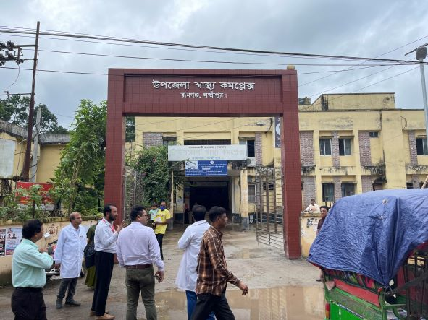
Fig-1: Front Gate of the Ramganj UHC

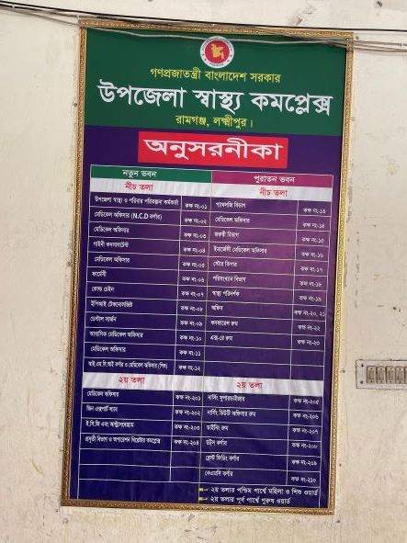

Fig-2: Guiding Board for location of the departments (Good Practice)

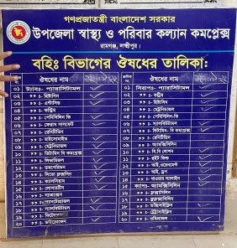

Fig-3: Supplying Drug List
(Good Practice)

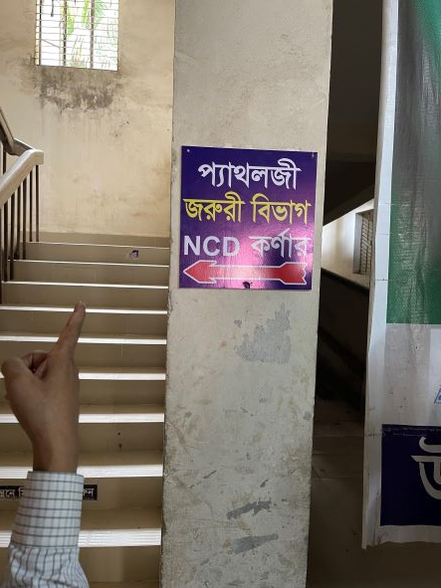
Fig-4: Guiding Sign for departments (Good Practice)

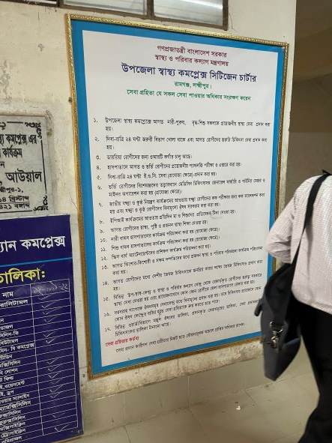

Fig-5: Citizen Charter (Good Practice)

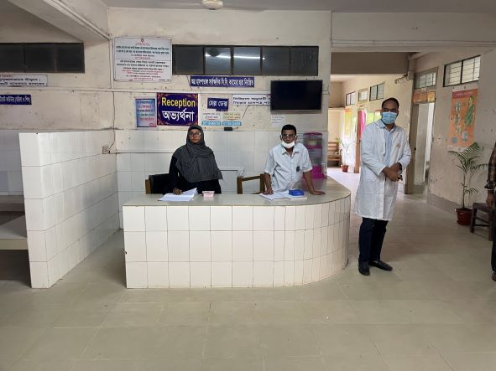

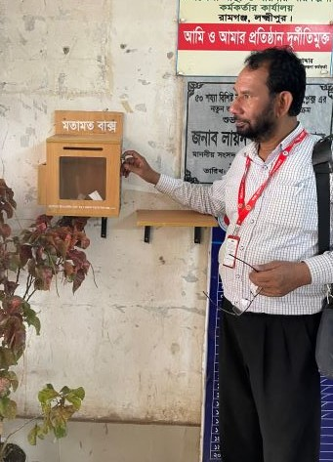
Fig-6: Reception Desk

Fig-7: Suggestion Box (Good Practice)

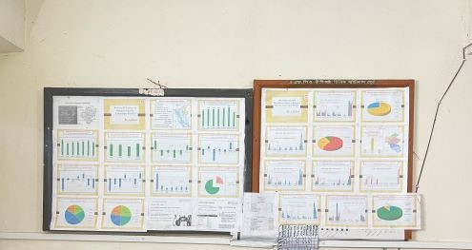
Fig-8: Updated Display Board of Office room (Good Practice)
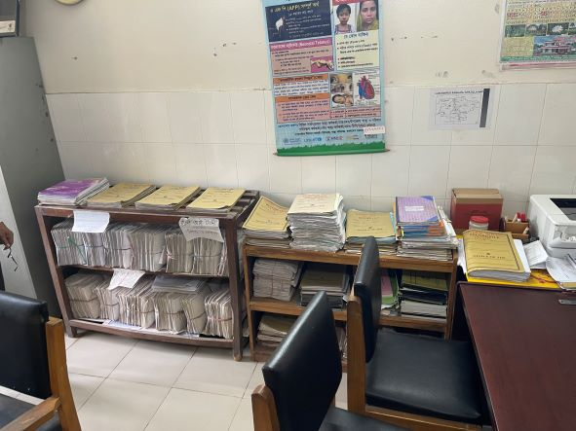

Fig-9: Organized Office filing system (Good Practice)

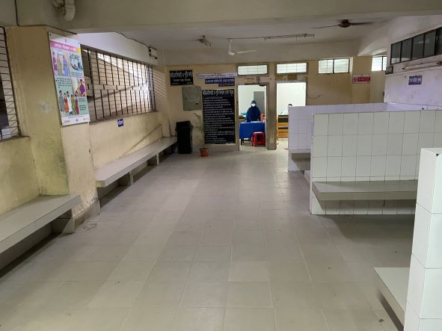
Fig-10: Proposed area for giving health education for patients and their attendants
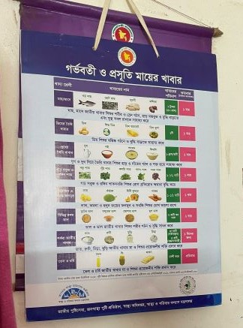

Fig-11: Nutritional chart for pregnant (Good Practice)

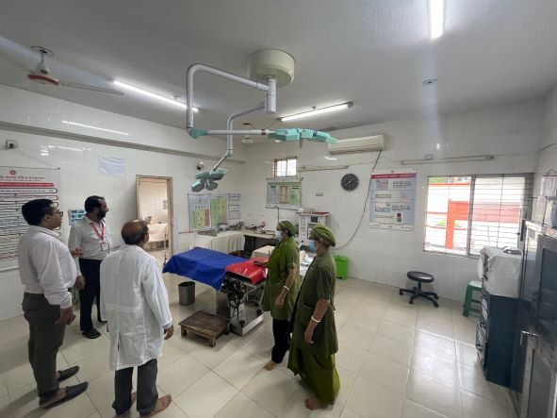

Fig-12: Functional OT room
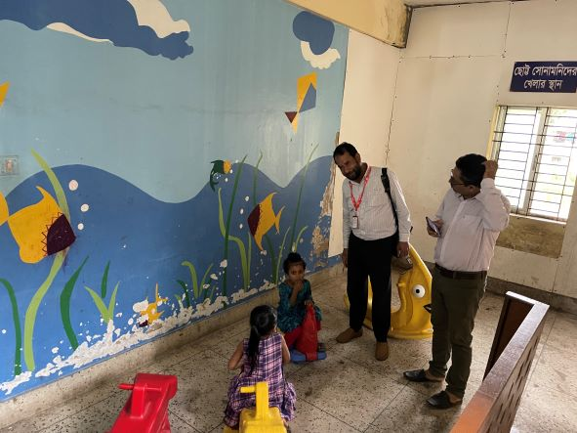

Fig-13: Kid’s Corner (Good Innovation)
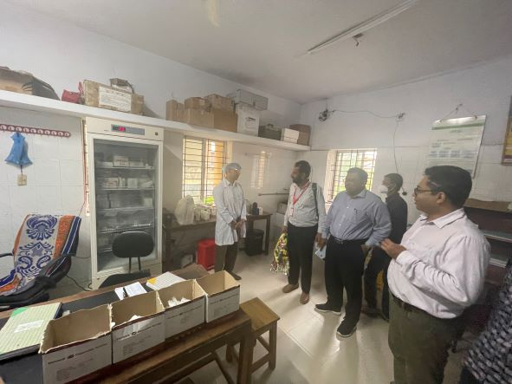

Fig-14: Organized Pathology room
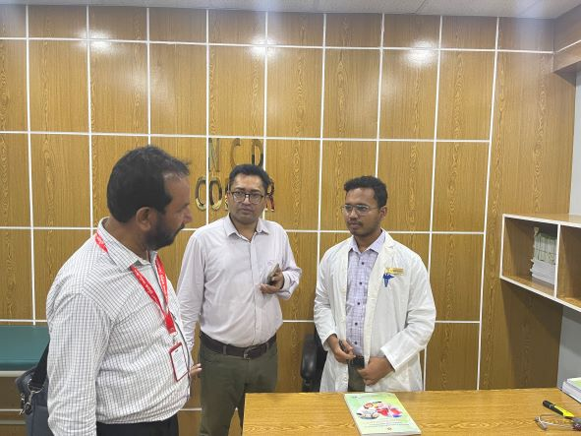

Fig-15: NCD Corner
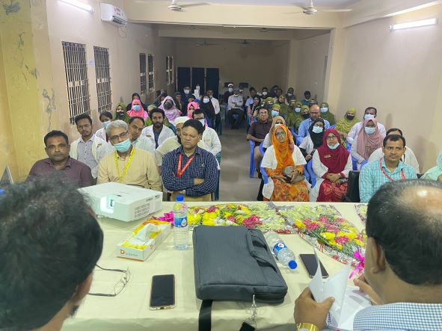

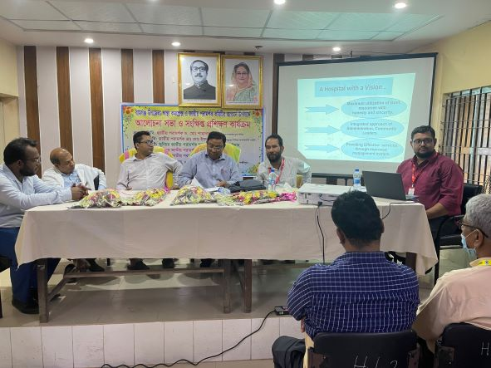

Fig-16: Discussion on SSK and Health Care Quality with Hospital Staffs

Fig-17: Participants of the Discussion session

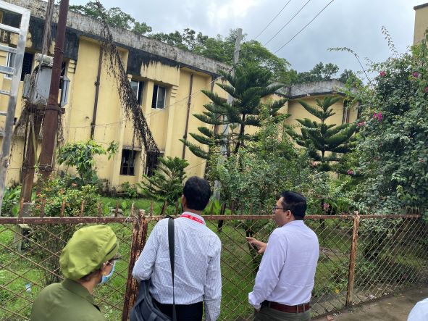

Fig-18: Unclean garden area in front of the health complex
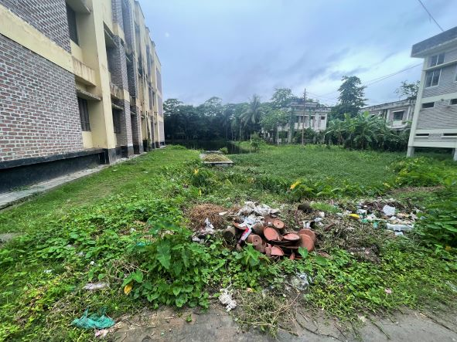
Fig-19: Unclean area behind the health complex

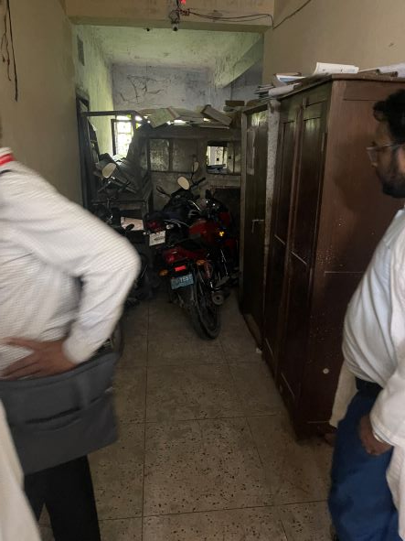
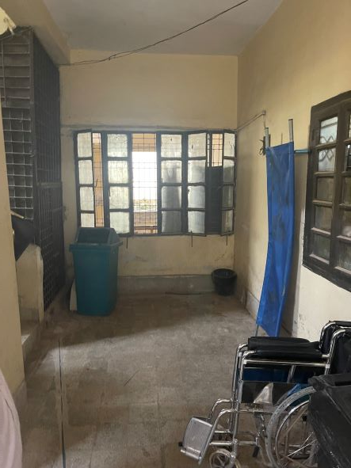

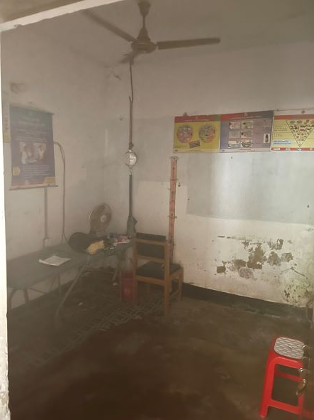
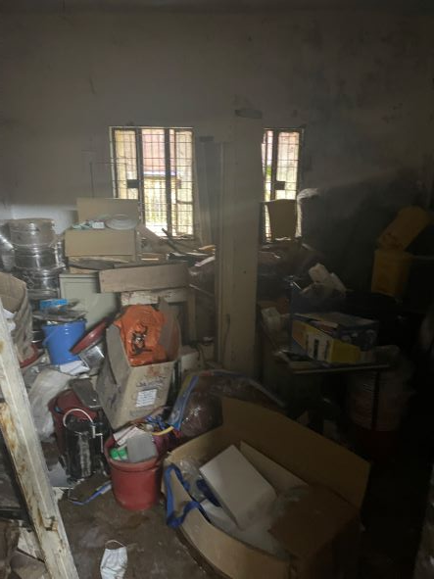

Fig-20-23: Proposed areas for SSK booth and SSK Pharmacy
Visit Report: Kamalnagar Upazila Health Complex, Lakshmipur
Date of Visit: 13/09/22; Time: 9:00 AM.
Visitor: Dr. Md. Emdadul Haque, National Consultant (SSK) &
Dr. Nazmur Rahman Sajib. Junior National Consultant (SSK)

Objectives of the visit:
1. To assess the progressive development of the quality of health care
2. Discussion about the importance of quality of health care.
3. Formation of quality improvement committee (QIC)
4. Improvement of the quality by implementing the building blocks of C-J Model.

Activities at UHC:
1. We arrived at Kamalnagar UHC at 9:00AM, and participate in a discussion meeting regarding the importance of quality of health care with UH&FPO, RMO and other members of Quality Improvement Committee (QIC) in the conference room. Dr. Nazmur Rahman Sajib discussed about the importance of quality of health care by a power point presentation & Dr. Emdadul Haque discussed about the building blocks of C-J Model. We also discussed with them about SSK program and the overall situation of health complex.

2. We observed the development of UHC's healthcare services while performing a site inspection of the hospital. We have seen lot of improvements, such as those we had suggested on our earlier visit on 1st August 2022, including improvements to the cleanliness, beautification, and waste management systems.

Positive changes are shown below:
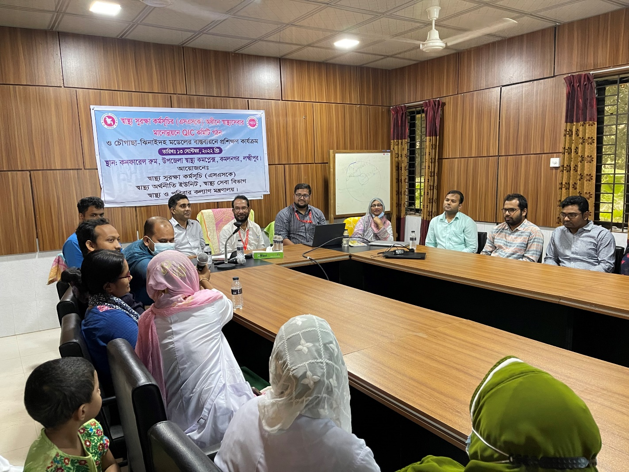

Fig-1: Training on Quality of Care and formation of QIC committee

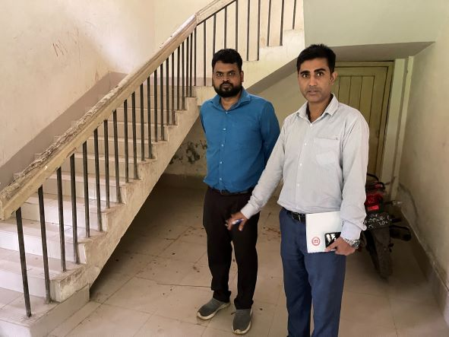
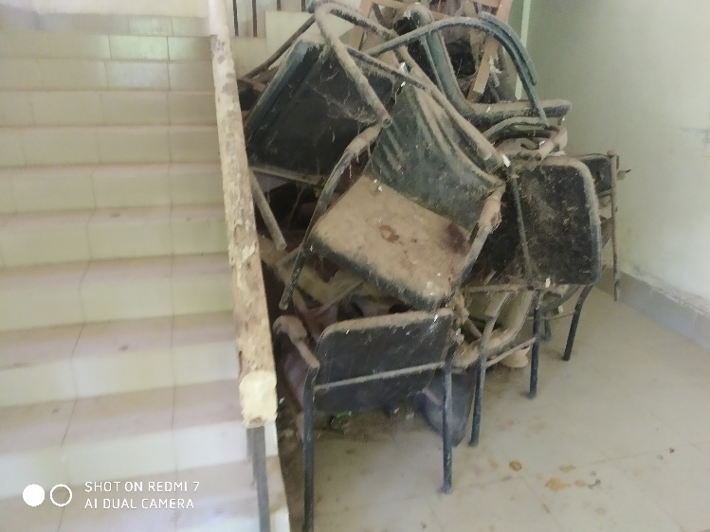
AFTER
BEFORE

Fig-2,3: Removal of unwanted items from hospital premises (Positive Changes)

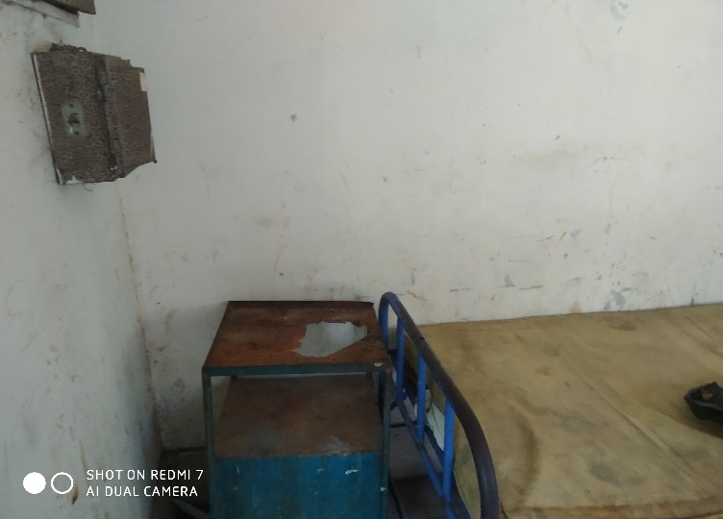
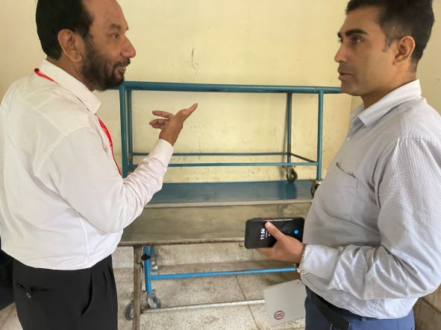
AFTER
BEFORE

Fig-4,5: Removal of unwanted items from hospital premises (Positive Changes)

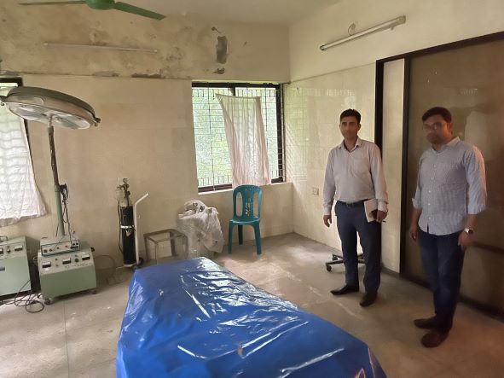
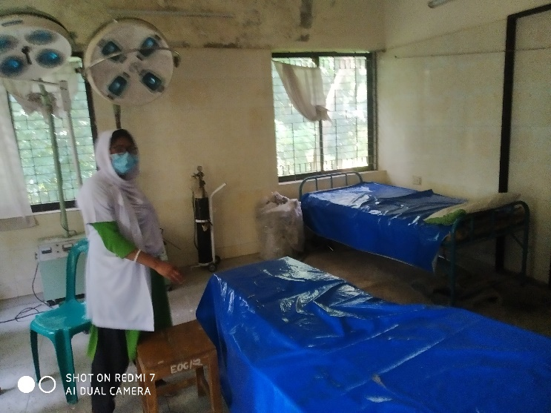
AFTER
BEFORE

Fig-6,7: Removal of unwanted items from OT (Positive Changes)

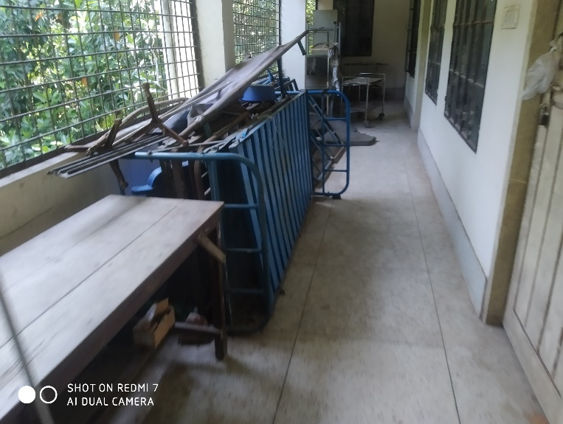
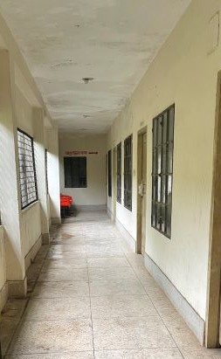
AFTER
BEFORE

Fig-8,9: Removal of unwanted items from the corridor (Positive Changes)

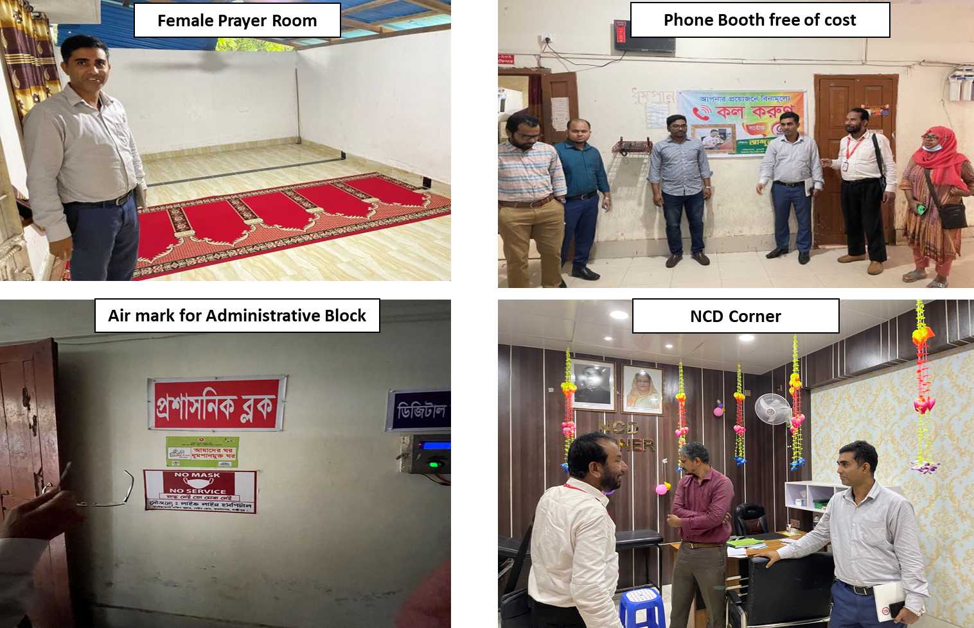

Fig-10-13: New Innovations by UHC

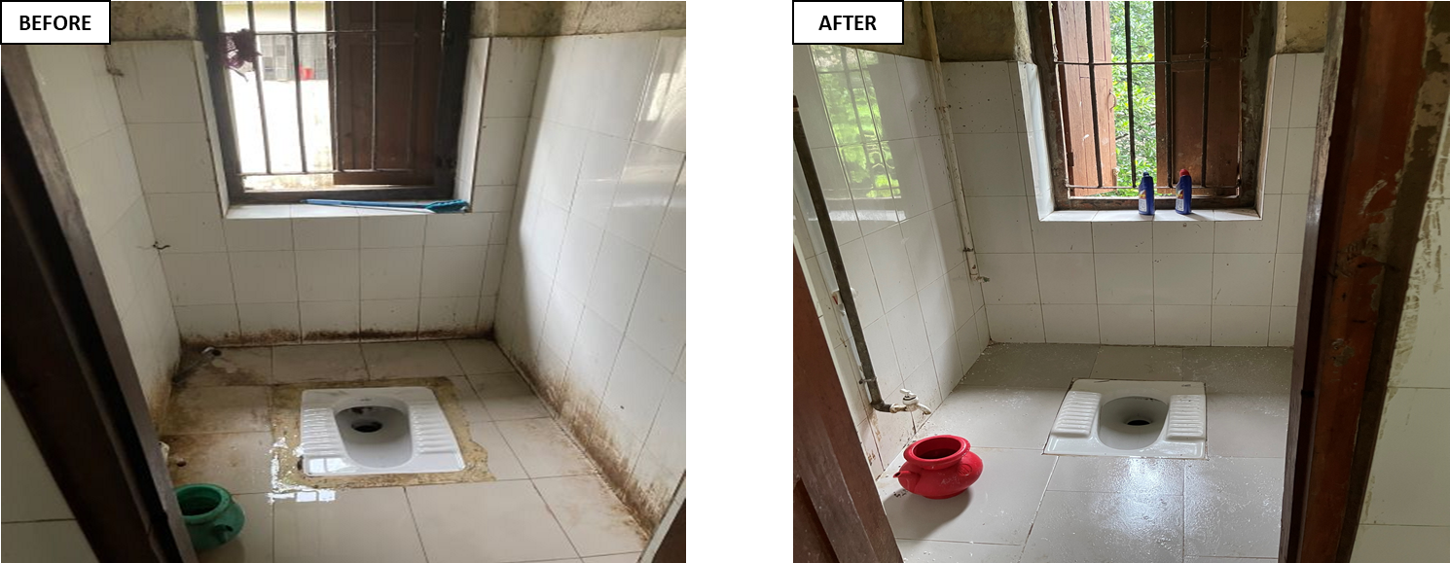

Fig-14,15: Improved sanitation system (Positive Changes)
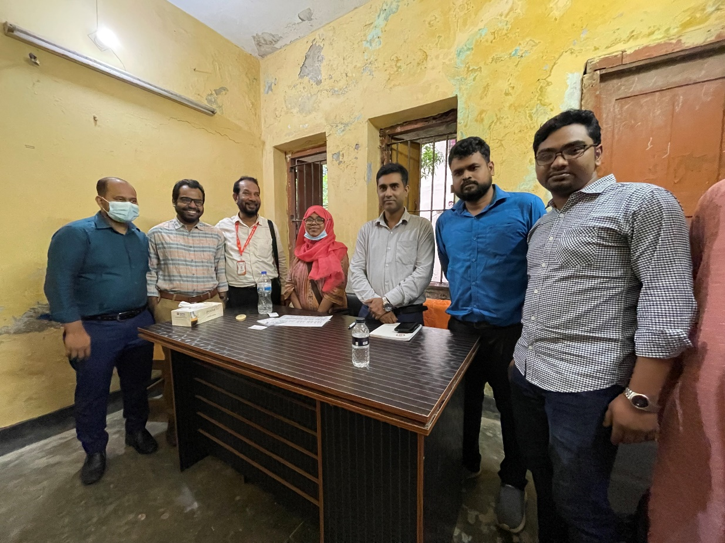

Fig-16: New desk funded by Medical Officer

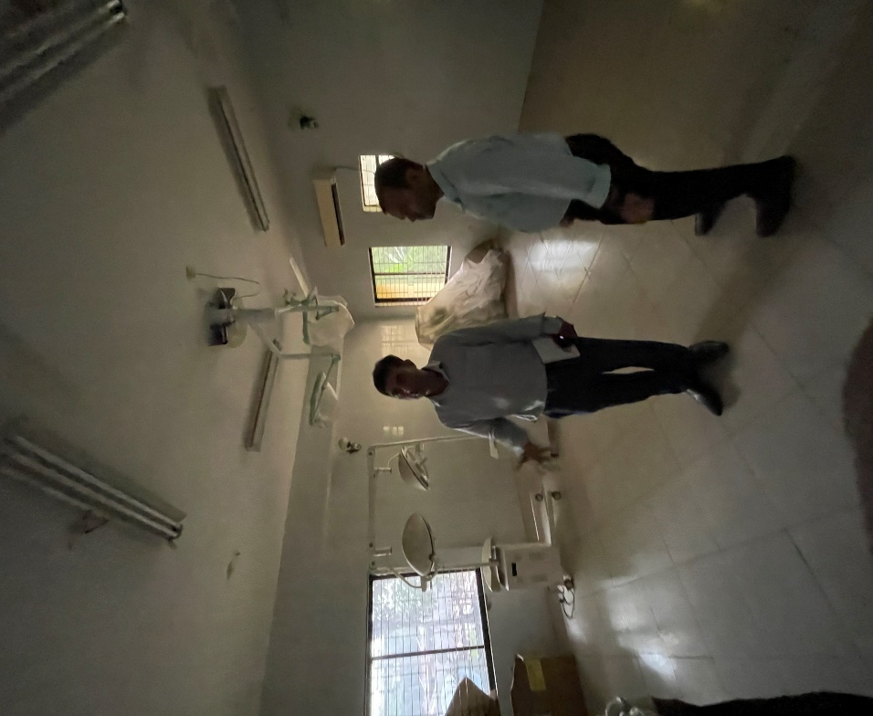

Fig-17: Preparation of OT room in new building

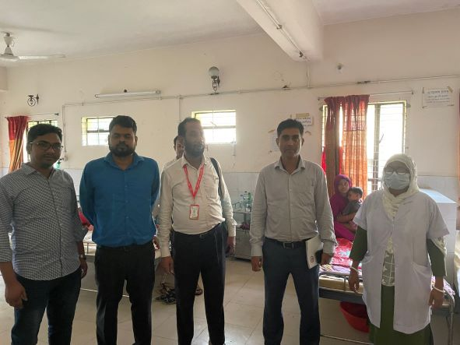
Fig-18: Opened a pediatric ward by local initiatives

Recommendations:
1. For functioning of the OT service, deputation of gynae consultant should be cancelled. An anaesthesia consultant already working there. But there is no anesthesia machine and OT table, which can be replaced from the other UHC where extra machine is available.
2. There are some proposed places near emergency dept. where SSK booth and Pharmacy can established.

Visit Report: Ramgati Upazila Health Complex, Lakshmipur
Date of Visit: 13/09/22; Time: 1:00 PM.
Visitor: Dr. Md. Emdadul Haque, National Consultant (SSK) &
Dr. Nazmur Rahman Sajib. Junior National Consultant (SSK)

Objectives of the visit:
1. To assess the progressive development of the quality of health care
2. Discussion about the importance of quality of health care.
3. Formation of quality improvement committee (QIC)
4. Improvement of the quality by implementing the building blocks of C-J Model.

Activities:
1. We arrived at Ramgoti UHC at 1:00 pm and participate in a discussion meeting regarding the importance of quality of health care with UH&FPO, RMO and other members of Quality Improvement Committee (QIC) in the conference room. Dr. Nazmur Rahman Sajib discussed about the importance of quality of health care by a power point presentation & Dr. Emdadul Haque discussed about the building blocks of C-J Model. We also discussed with them about SSK program and the overall situation of health complex.
2.We met with the Upazilla Chairman, as he came to the UHC. He assured us that he will take part in the renovation of labour room, OT room and build two cabins in the health complex. He also assures us a water ambulance for the people of Char-Abdullah should be donated by Upazilla Parishad very soon.
3. We observed the development of UHC's healthcare services while performing a site inspection of the hospital. We have seen lot of improvements, such as those we had suggested on our earlier visit on 1st August 2022, including improvements to the cleanliness, beautification, and waste management systems. They have started to perform C-Section by the support from district authority.
The positive changes are shown below:
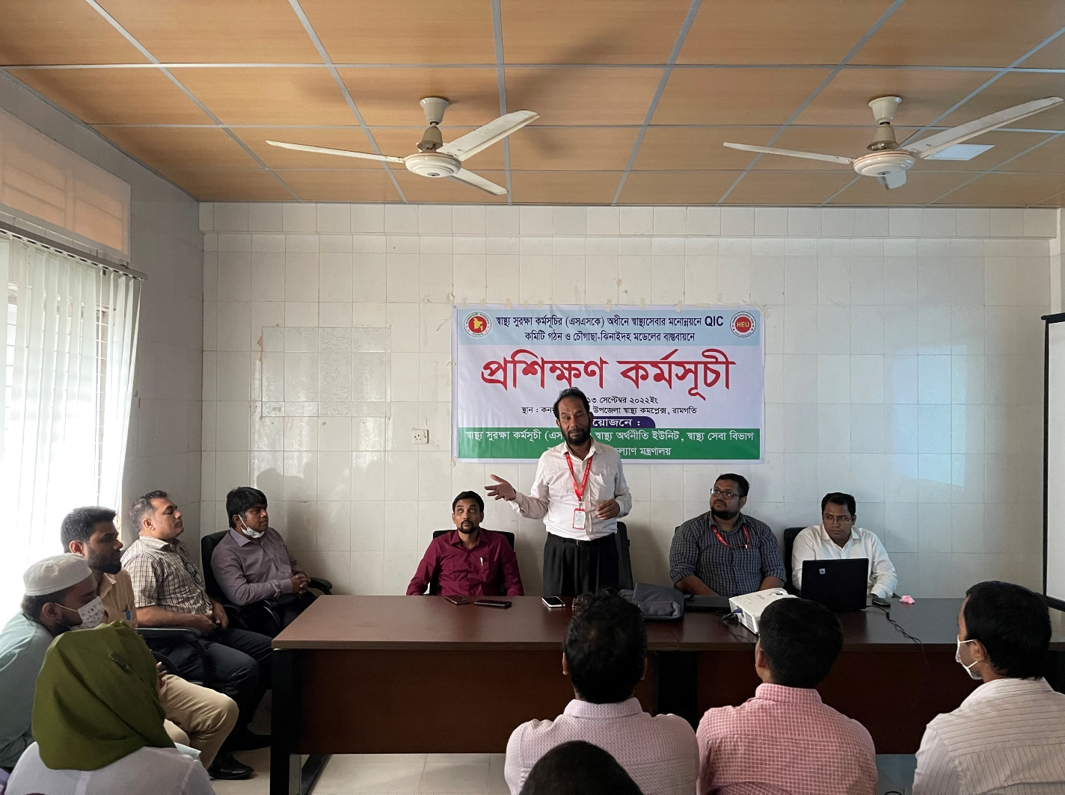

Fig-1: Training on Quality of Care and formation of QIC committee

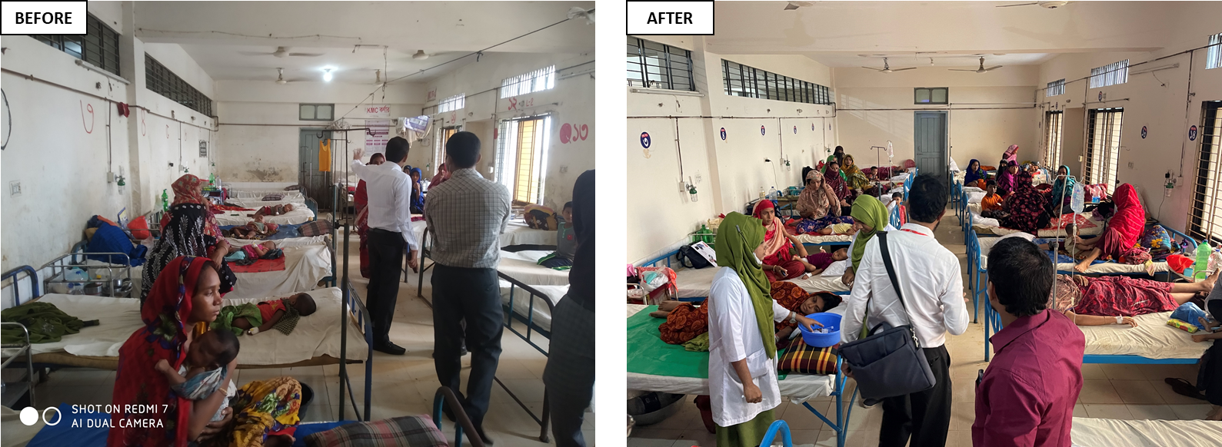

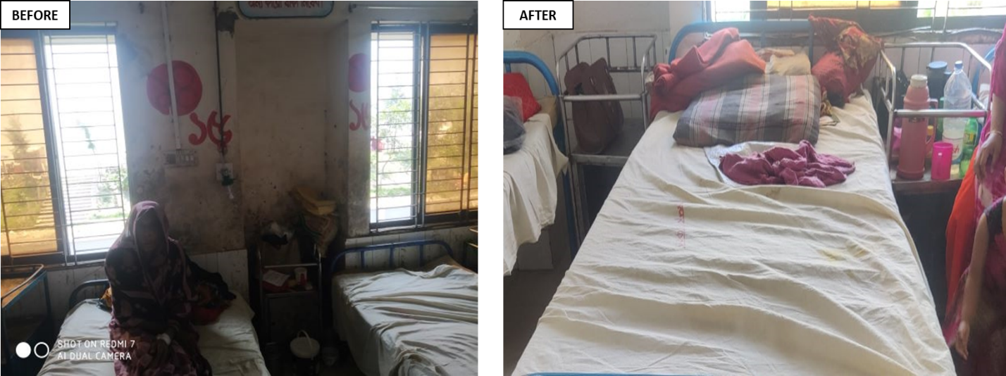

Fig-2-5: Positive changes in Female Ward

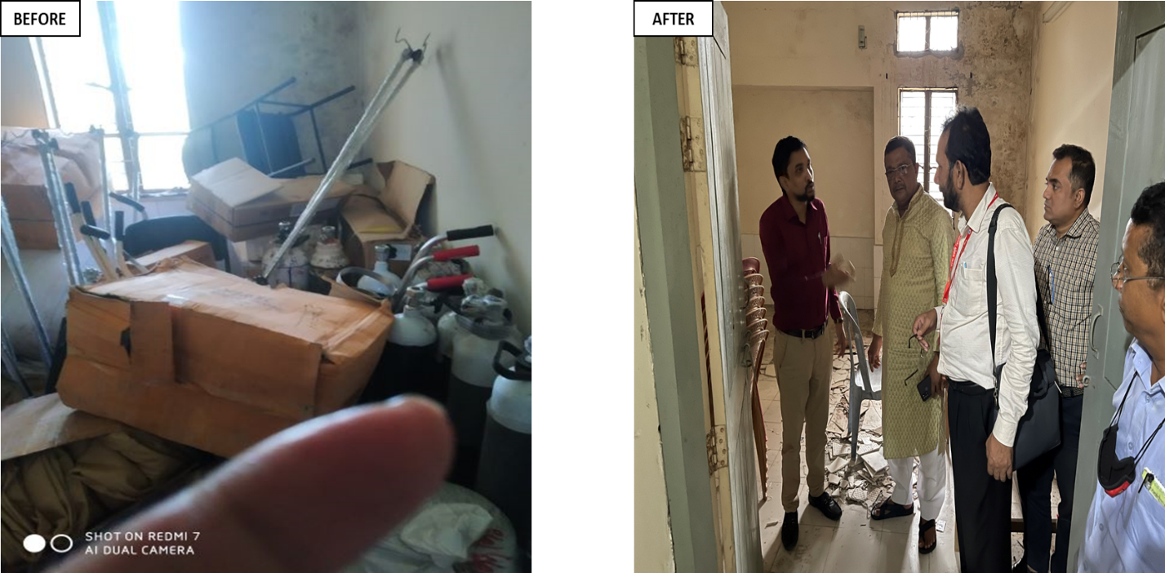

Fig-6,7: Removal of unwanted items for Labour room

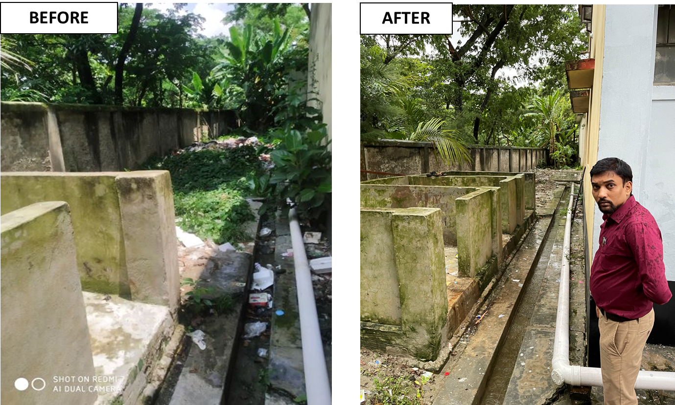

Fig-8,9: Improvement of waste management system

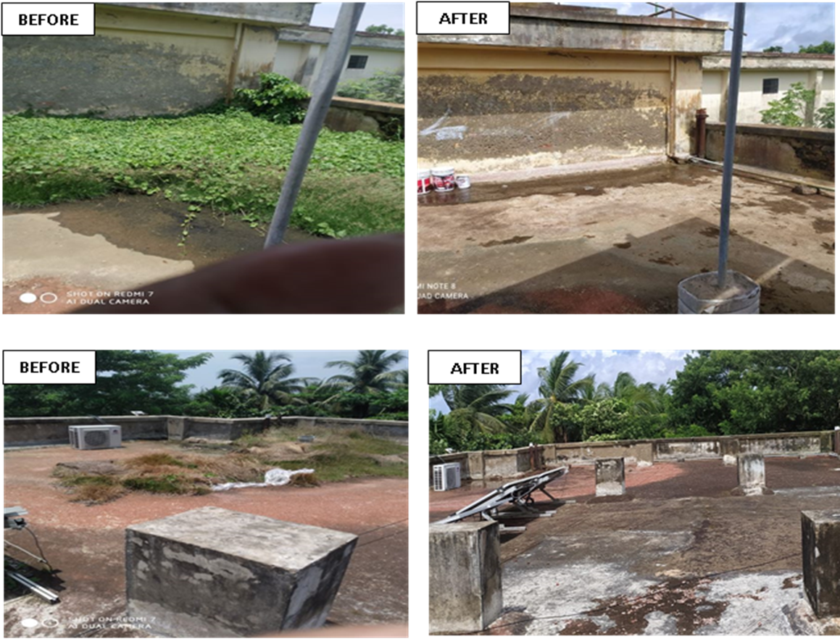

Fig-10-13: Changes in the rooftop of the UHC

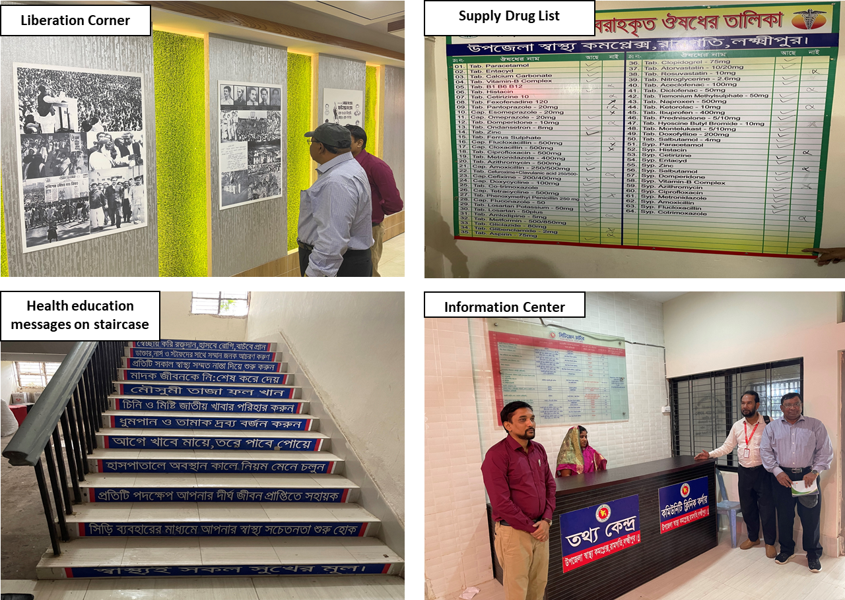

Fig-14-17: Innovation of Ramgati UHC

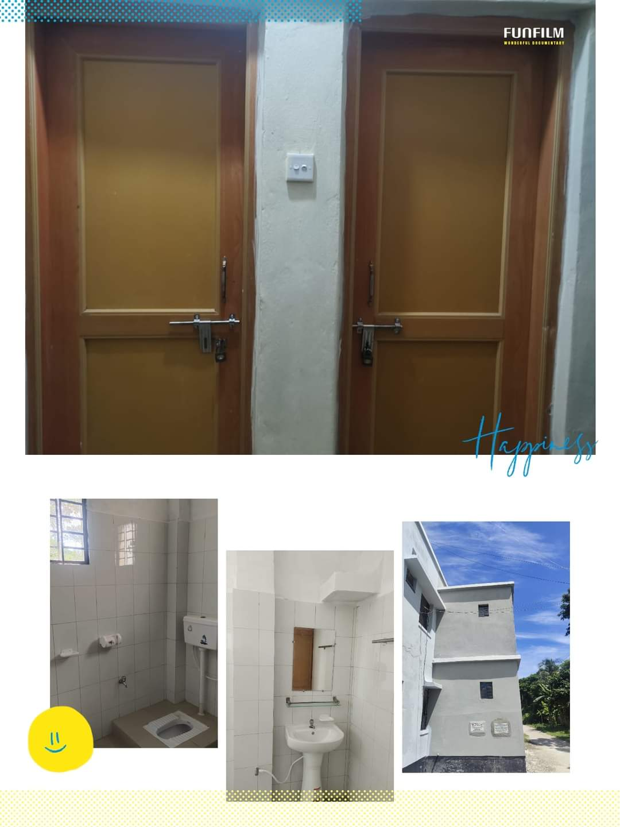

Fig-18: Newly constructed 4 washroom for patients
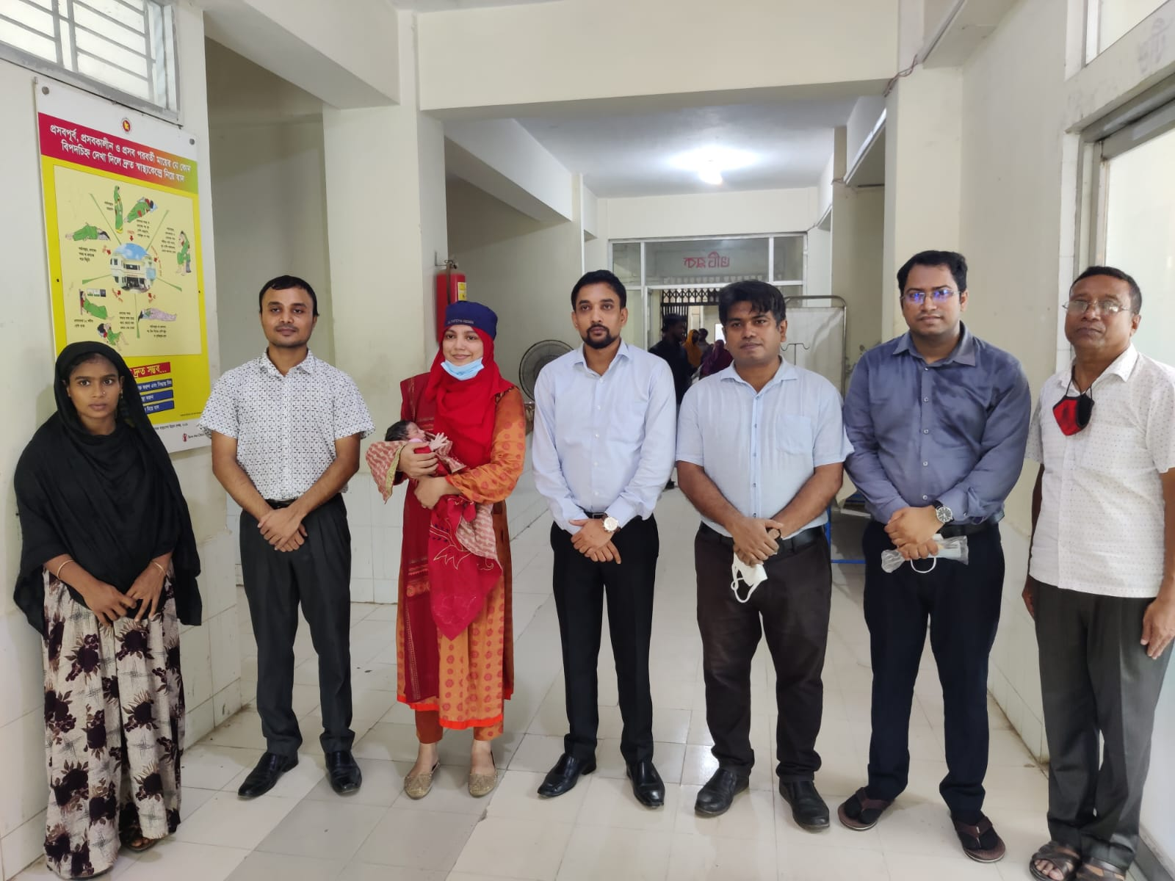

Fig-19: C-section restarted by the support of Civil surgeon

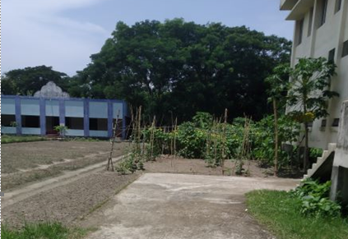

Fig-20: Vegetable Garden in UHC Campus

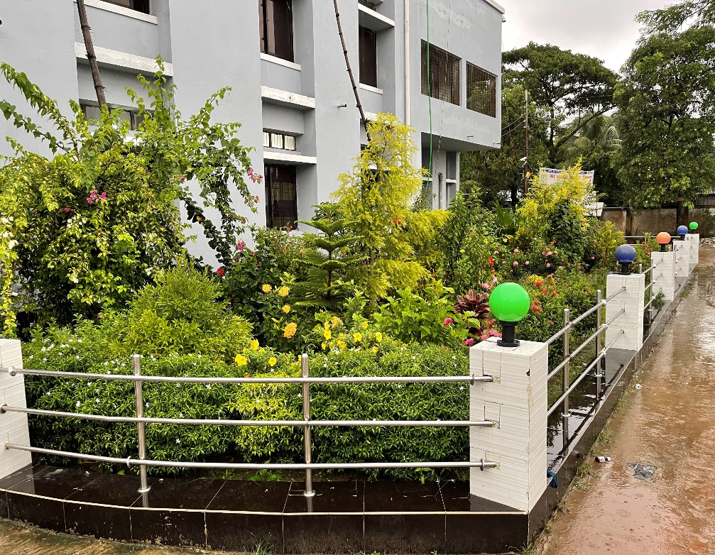
Fig-21: Beautiful Garden in front of UHC

Recommendations:
1. The post of Gynae consultant should be filled immediately to develop effective maternal health services.
2. The UHC is 31 bedded hospital. The bed occupancy rate of the hospital is more than 100%. So, rooftop of the hospital can be used for ward and administrative offices by forming tin shed infra-structure.
3. There are two places selected for SSK booth and pharmacy which needs reconstruction.

Visit Report: 100 Bedded Sadar Hospital, Lakshmipur.
Date of Visit: 14/09/22; Time: 9.00 AM.
Visitor: Dr. Md. Emdadul Haque, National Consultant (HEU) &
Dr. Nazmur Rahman Sajib, Junior National Consultant (HEU)

Objectives of the visit:
1. To perform the baseline health survey of the 100 bedded Sadar Hospital.
2. Discussion on the SSK program and importance of quality of health care.

Activities:
1.We arrived at 9.00 am in the hospital. Superintendent, consultants were present. We discussed with them about the overall situation of the hospital. We also discussed with them about the SSK program and role of the District Hospital in SSK.
2. Though the hospital is 100 bedded, but is running with 50 bedded human resource since 2003. There are 11 posts of consultants but 6 are vacant. One post of senior consultant gynae is there but vacant for a long period. The caesarian section is performing by medical officer having post-graduation degree.
3. There is no post of cashier, accountant and statistician. So, office management is difficult. There are three cleaners working in the hospital. There is no Aya, ward boy, and trolley-man.
4. The infra-structure of this hospital is 100 bedded. The physical condition of the hospital building is not satisfactory. There is another 150 bedded infra-structure building is under construction. There are occupied spaces in front of the under constructed building which hampers the external environment of the hospital.
5. We visited outdoor of the hospital which was crowded with patients. We also observed Emergency, pathology and pharmacy department. The information display system was not satisfactory. There was no effective health education system.
6. Cleanliness of the hospital premises and indoor was weak. There are separate operation theatres for performing major operations.
7. There is no cycle stand close to the main gate. There are many motorcycles parked within the premises.
8. The roof of the hospital was not clean.
9. There are spaces for SSK Booth and Pharmacy close to the emergency department.
10. In 2021, total OPD patient was 2,84,535. Indoor admitted patient was 29,277. Bed occupancy rate was 252%. Total ANC 1st visit in 2021 was 7350. Total delivery was 2176. Among them NVD was 1744, C-section was 432.

Human Resources of 100 Bedded Hospital: (running with 50 bedded human resource)
Sl. | Designation | No. of Post | Present | Vacant
 | Superintendent | 01 | 01 | 0
 | RMO | 01 | 01 | 0
 | Senior Consultant | 04 | 01 | 03
 | Junior Consultant | 07 | 05+03 (dupt.) | 02
 | Medical Officer + EMO | 06 | 05 | 01
 | MO(Dental) | 01 | 0 | 01
 | Medical Officer (OSD)  (Local order) | - | 13 | -
 | Nurses (Nursing Super+ SSN) | 2+87=89 | 2+67=69 | 20
 | Mid wives | 04 | 03 | 01
 | MT (Lab)  **One in higher education, 1 in deputed at Kurmitola Hospital  ** Running by Lab attendant | 02 | 02 | 0
 | MT(Dental) | 01 | 01 | 0
 | MT (Radiology) | 01 | 0 | 01
 | Pharmacist | 03 | 02 | 01
 | Head Assistant | 01 | 01 | 0
 | Cashier | 0 | 0 | 0
 | Accountant cum comp operator | 01 | 01 | 0
 | Statistician (No Post) | 0 | 0 | 0
 | Store Keeper | 01 | 01 | 0
 | Cardiographer | 0 | 0 | 0
 | MLSS+ Ward boy | 10 | 03 | 07
 | Cleaner | 04 | 03 | 01
 | Guard (outsourcing) | 02 | 02 | -
 | Gardener + Herbal Gardener | 01 | 01 | 0
 | Outsourcing: | 02 | 0 | 02
 | Driver | 03 | 03 | 0
 | Cook | 03 | 02 (one from outsourcing) | 01

Status of Building Blocks of C-J Model in the Lakshmipur Sadar Hospital:
Sl | Criteria of C-J Model | Satisfactory | Average | Weak
01 | Cycle stand close to the main gate |  |  | √
02 | Health Education |  |  | √
03 | Cleanliness & beautification |  |  | √
04 | Separation of patients in out door & indoor |  | √
05 | Blood donor list with 24/7 B.T facility |  | √
06 | Death Riview |  | √
07 | Reception Desk |  |  | √
08 | Developed Emergency Dept. |  | √
09 | 5S –KAIZEN implementation. |  |  | √
10 | Community Participation. |  |  | √
11 | Hospital activities Display |  |  | √
12 | Corner based service. |  | √
13 | Cash counter for receiving Govt money. |  |  | √
14 | Devolped maternal health/labour word. |  | √
15 | Devolped paediatric health | √
16 | Position in HSS score in July22.  (Best <10; Good 10-20; Weak >20) |  |  | √
17 | Power point Presentation &Video on UHC |  | √
18 | Knowledge about 8th Five Year plan & SDG. |  |  | √
19 | Zero-Tollarance on corruption |  | √

Recommendations:
1.The post creation of human resource of 100 bedded hospital is very essential to maintain the quality of health services.
2. Cleaning and beautification is not up to the mark. For waste management, involvement of Pouroshova is necessary. Pouroshova can take part in providing cleaners for the hospital like other district hospitals of the country.
3. Acquiring the areas in front of the under constructed hospital building is necessary. There is a pond behind the bulding which is also needs to be acquired.
4. All the vacant posts of consultants should be fullfilled. Senior consultant Gynae should be posted immediately. All the vacant posts of 3rd and 4th class should also be fulfilled.
6. Condemetion Board should work to destory all unwanted items.
7. There should be availability of safe drinking water.
8. Display system should be updated regularly and health education for the patients and their attendants should be introduced.
9. There should be 24/7 facility for caesarean section.
10. Toilet of the labor room should be repaired for the labor patients.

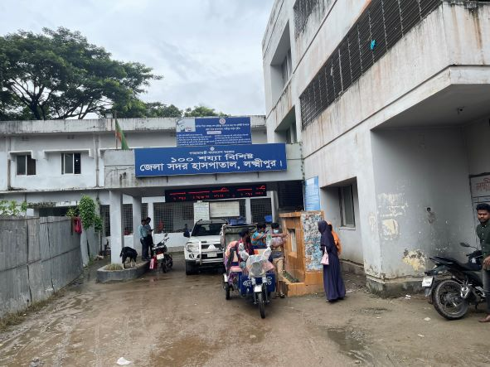
Fig-1: Entrance gate of Sadar Hospital

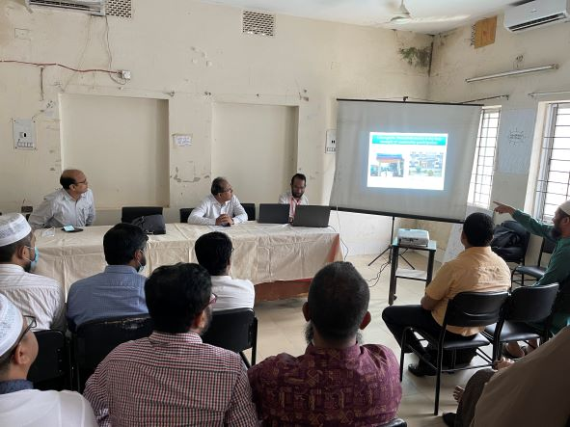

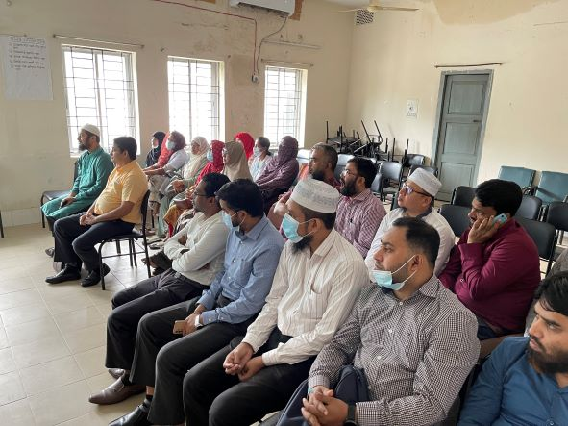

Fig-2,3: Discussion on SSK and Quality of Health Care with Doctors

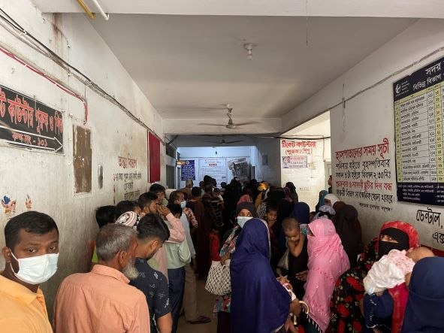

Fig-4: Overcrowded OPD

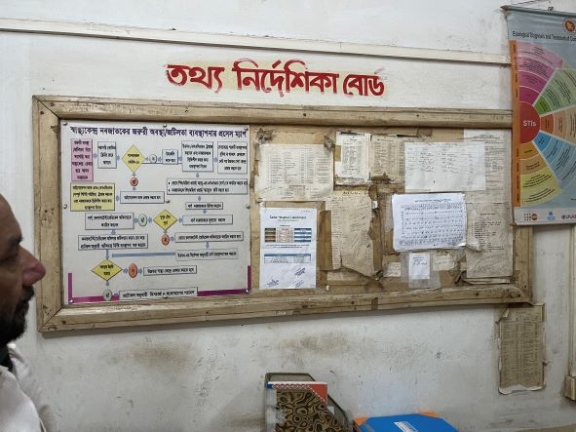

Fig-5: Display board not attractive and updated

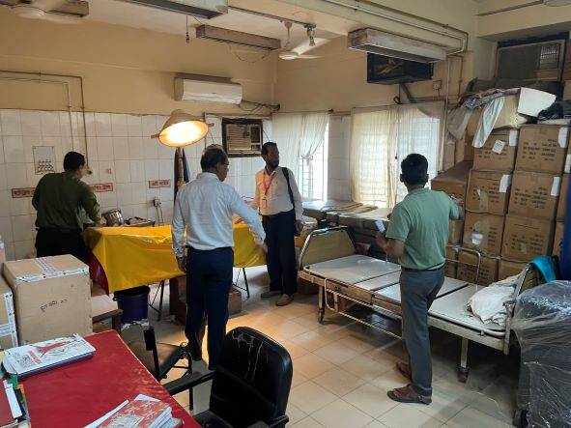
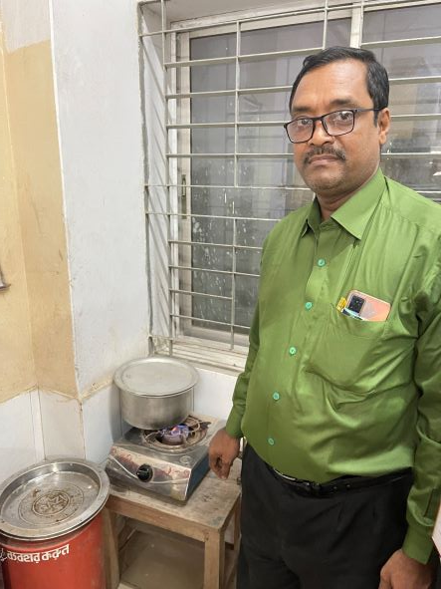
Fig-7: Disorganized emergency OT
Fig-6: Sterilization of the instruments of Emergency Dept. (Good Practice)

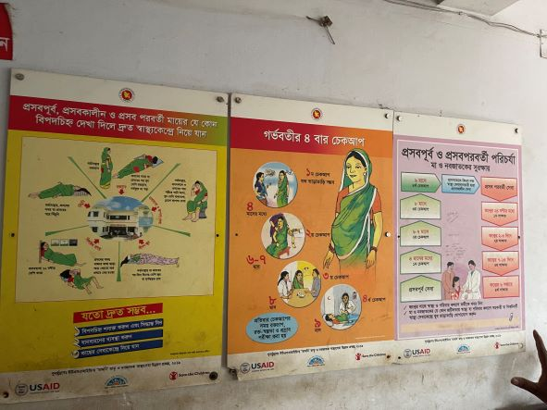

Fig-8: Information Display followed the KAIZEN rule
(Good Practice)

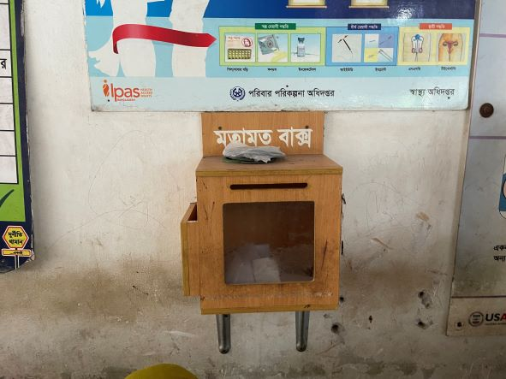

Fig-9: Suggestion Box
(Good Practice)

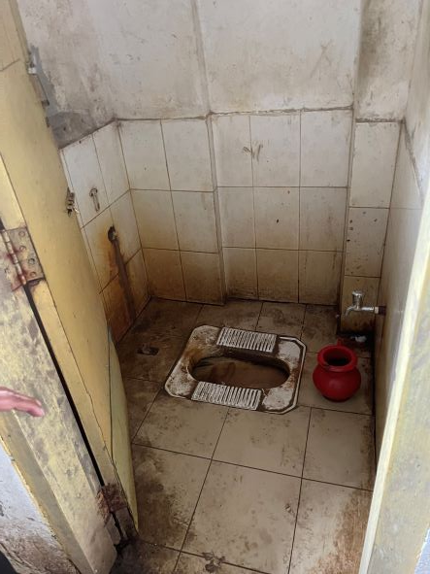
Fig-10: Unclean Toilet in outdoor

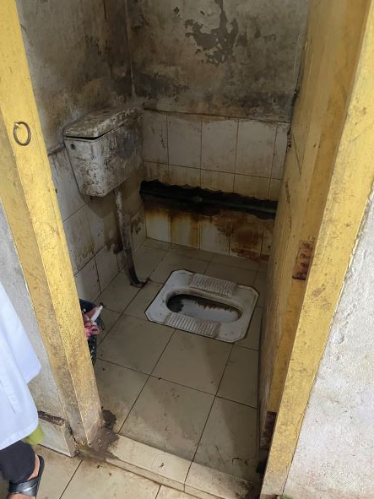

Fig-11: Unclean Toilet in indoor

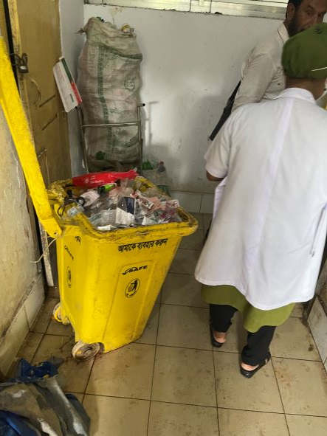
Fig-12: Weak waste management system

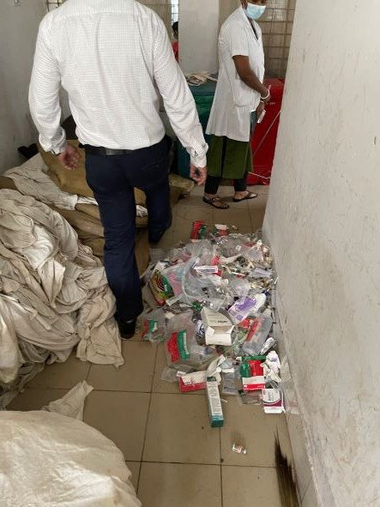
Fig-13: Weak waste management system

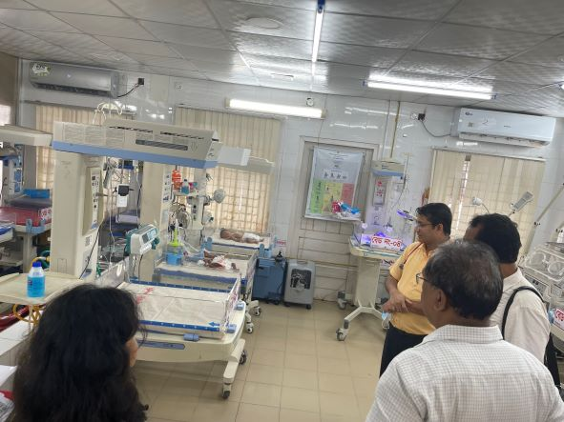

Fig-14: Developed Neonatal Care Unit (Good Practice)

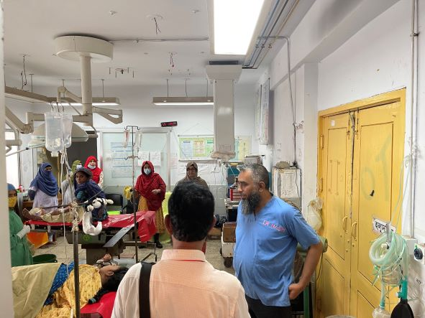

Fig-15: Disorganized OT

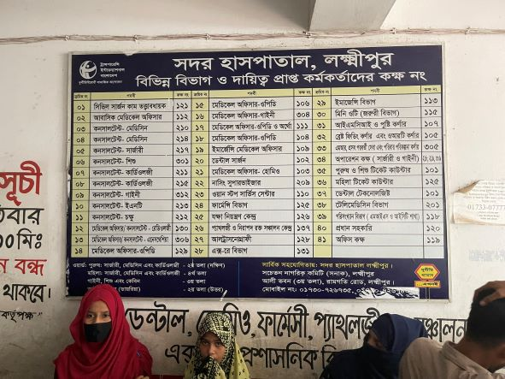
Fig-16: Position Board (Good Practice)

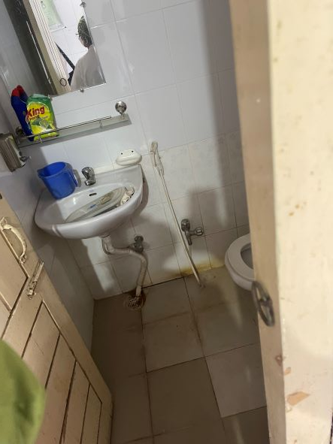

Fig-17: Labor room toilet, but cannot be used by labor patient

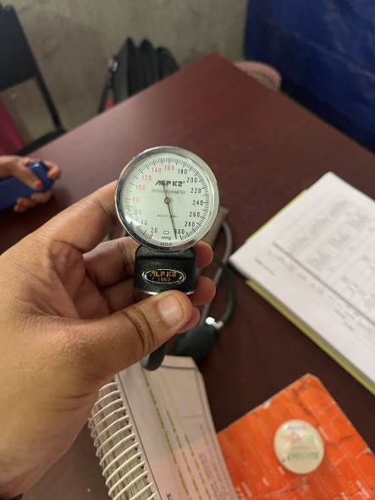

Fig-18: Inaccurate BP machine using in indoor

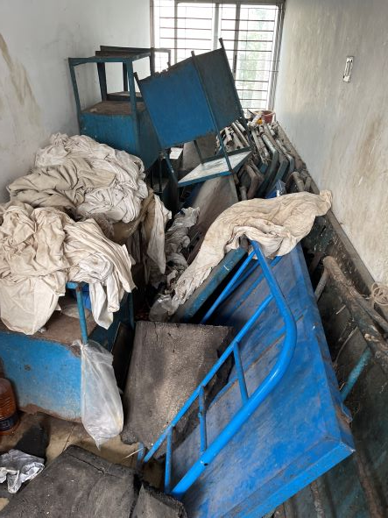

Fig-19: Unwanted items occupied the space of indoor

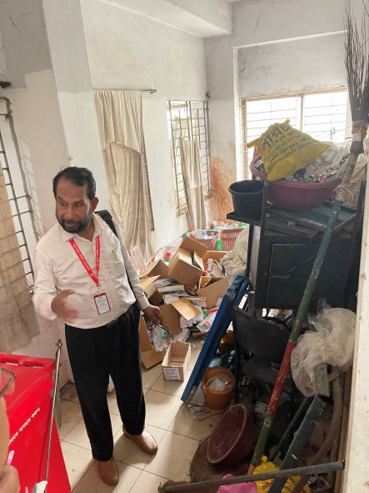

Fig-20: Unwanted items occupied the space of indoor

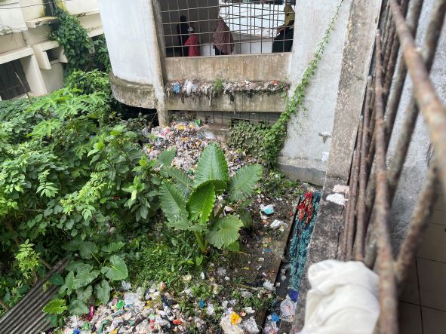

Fig-21: Weak waste management system beside the Hospital building

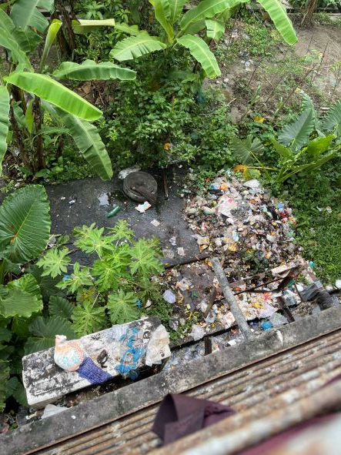
Fig-22: Weak waste management system beside the Hospital building

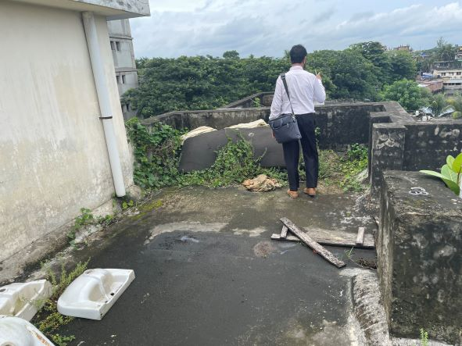

Fig-23: Unclean rooftop of the Hospital building

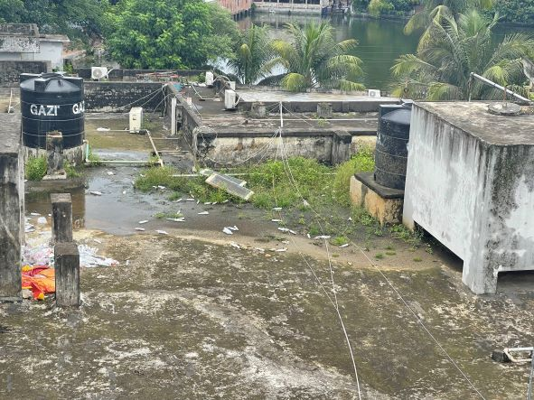

Fig-24: Unclean rooftop of the Hospital building

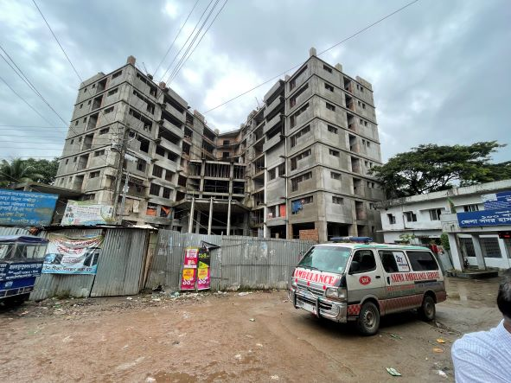

Fig-24: Under construction 150 bedded hospital building
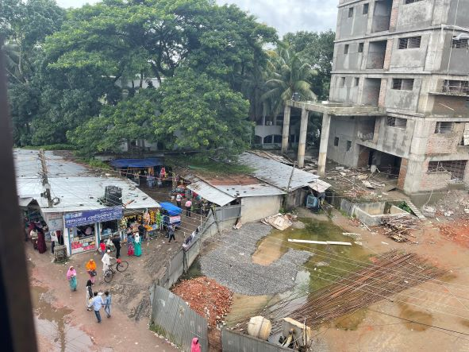

Fig-25: Acquirable important areas inside hospital compound

